

Operation Manual
Fully Automated Blood Rheology Analyzer
SA-9000

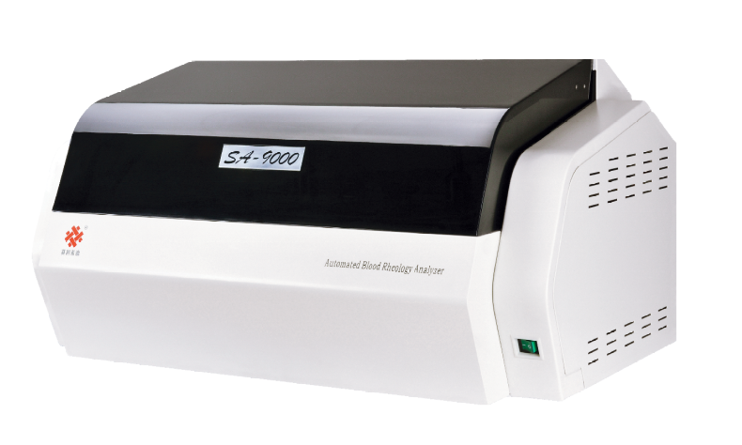

PLEASE READ THIS MANUAL CAREFULLY BEFORE OPERATION



Beijing Succeeder Technology Inc.
www.succeeder.com.cn | service@succeeder.com.cn

Effective Date:01/06/2016
SUCQF·T-CK-STAD-SA90-003(a)/A0
Contents
Product model: □SA-7000 □SA-9000 3
Warning and Attention Symbols 4
☆Important safety guidance 4
Quality commitment 5
1. Working principle 6
1-1 Principle overview 6
1-2 Calculation formulas (conversion parameters) 7
2. Technical Index 8
2-1 Application scope 8
2-2 Working environment and conditions 8
2-3 Main technical indexes 9
2-4 Contraindications 12
2-5 Service life 12
2-6 Storage condition 13
3. Test system composition and operating environment 14
3-1 Test system composition 14
3-2 Operating environment 14
4. Instrument Appearance and Marks 15
4-1 Rheometer appearance 15
4-2 Washing components 16
4-3 Rheometer rear view 16
4-4 Annex 17
5. Instrument Installation and Connection 18
5-1 Installation place 18
5-2 Instruments connection 18
5-3 Access/Exit test program 19
6. Menu operation 21
6-1 [Report] item operation 21
6-2 [Check] item operation 22
6-3 [Setting] item operation 25
6-4 [User] item operation 26
7. Test operation 28
7-1 Pre-test preparation 28
7-2 Batch test 28
7-3 Single sample hole test 30
7-4 Batch entry of patients’ information 30
7-5 Test procedure 31
7-6 “Test” menu item operation 31
7-7 “Search” menu item operation 32
7-8 Test result display 32
7-9 Viscosity - shear rate curve 34
8 [Set] item operation 36
8-1 “Cone-plate calibration” menu item operation 36
8-2 “Capillary calibration” menu item operation 37
8-3 “system detection” menu item operation 38
8-4 “Manual test” menu item operation 39
8-5 “Non- Newtonian quality control” menu item operation 40
8-6“User information” menu item operation 41
8-7 “External instrument” menu item operation 41
8-8 “Network” menu item operation 42
8-9 “Normal(N) value” menu item operation 42
8-10 “Alarm limit” menu item operation 43
8-11 “Shear rate” menu item operation 44
8-12 “Test item” menu item operation 45
8-13 “Library” menu item operation 45
8-14 “Analysis report” menu item operation 46
9 Test report design 47
9-1 Custom report 47
9-2 New report 47
10 Sample collection and preparation (Note: only for clinical reference) 49
10-1 Anticoagulant selecting and dosage 49
10-2 Sample collection 49
10-3 Blood plasma preparation 50
10-4 Sample storage 50
11. Routine maintenance 51
12. Basic troubles shooting 52

Communication methods
Thank you for purchasing our products!
Before your first use of this equipment, please read the operation manual carefully!
Product model: □SA-7000 □SA-9000 | Name: Fully automated blood rheology analyzer
Manufacturer: Beijing Succeeder Technology Inc.
Special line (free) for after-sales service and maintenance: 0086-10-53855569
Special line (free) for customer complaint: 0086-10-53855569
Fax: 86-10-53855570
Registered address: 1A Building, 27 Chuangxin Road, Beijing Changping Science Park, China
Production address: 3rd Floor, 1 Building, 1 Xingchang Road, Beijing Changping Nanshao Science Park, East District, China Postcode: 102200
http://www.succeeder.com.cn
E-mail: service@succeeder.com.cn

If you purchased the equipment from the dealer authorized by Succeeder, please do remember the contact information!
Dealer:
Contact number:
Fax:
Address::

Please record the following information and must notify us after installation, so that we can establish your archives and timely provide you with more and better services and communications!
Username:
Laboratory name:
Instrument No.: | Operation person in charge:

Warning and Attention Symbols

Warning:
You must follow the instructions, to avoid harming human body.
☆ Attention:
The important information and useful tips in operation or maintenance
Caution and danger, the person in charge or the operating personnel needs to refer to the manual.

☆ Important safety guidance
Before installing and first time using the equipment, please read the following guidance. Equipment operation must follow the using method regulated in the manual, or, it is likely to damage the protection provided by the equipment.
◆ Net power source must possess protective ground terminal. Equipment inner protection ground terminal shall mark the symbol, which must have reliable ground via power socket. Net power source input socket is a disconnecting device of equipment and power source, which should not be installed in the positions where are hard to disconnect net power source. In the place that is likely to be moist, it shall add to install leakage protector when using.
◆ Instrument nameplate marks instrument name, model, company name, factory number, rated power, source voltage, mains frequency, and input power, etc.
◆ In case of instrument external labels with warning symbol, it refers that it is operated by the operator. This manual has given detailed operating instructions, so please must follow the references.
◆ The instruments produced by Succeeder all have been taken protective measures in transportation packaging. After instruments are put into operation, generally, it should not be moved, so please user carefully.
◆ Unless this manual has already taken measures, or, please don’t open it for overhaul on his own, it will bring you dangers, such as touching high voltage or others. Those parts should be overhauled by professionals.
◆ The instruments produced by Succeeder, except for special instruments produced according to special requirements, are merely used indoors:
a) Instruments nearby have no electromagnetic interference, no strenuous vibration and no corrosive gas;
b) Indoor temperature should be (10～30) ℃; relative humidity should not exceed 70%; atmospheric pressure should be (86.0～106.0) kPa;
c) Instruments are not used for humid environment;
d) After packaging, the storage condition should be (-40～55)℃, the relative humidity should not exceeds 93%, and the indoor environment should have no corrosive gas and well-ventilated;
e) Instrument cabling ground terminal must have reliable ground connection via power socket. The place might being humid should add leakage protector;
f) Analyzers produced by Succeeder are all equipped with power regulator inside, thus, generally, it is unnecessary to connect external voltage regulators. Only when the external mains voltage fluctuation exceeds (220±22) V can UPS voltage stabilizer be used instead of normal voltage stabilizer.
◆ In case the following conditions happen, please turn off the power, unplug the power plug and let professionals to maintain:
a) When power cord, signal line, and plug have damage or breakage;
b) When instruments are exposed in the rain or water;
c) When instruments are dropped to be broken or the cases are damaged;
d) In case that instruments cannot have normal operation even if operate them according to the operation guidance in the operation manual;
e) In case that instrument features have obvious changes and those obvious changes cannot be eliminated after excluding sample, random accessory, manual operation, and other factors, it shall means that instruments are need to be repaired.

Quality commitment
Succeeder’s outgoing products have passes strict quality inspection, which completely conforms to the requirements of registered product standard; Succeeder’s analyzers have passed the security and performance test of medical equipment inspection authorities, which conforms to national and industrial standard and executes EU 98/79/EC instruction;
Succeeder has passed certifications of TUV Company, ISO13485 and ISO9001 system;
Succeeder would provide one year warranty and 7 years maintenance for the products manufactured by Succeeder.

1. Working principle

1-1 Principle overview
SA-7000 automated blood rheology analyzer/ SA-9000 automated blood rheology analyzer adopts cone/plate type measurement mode. The product imposes a controlled stress on the fluid to be measured through a low inertial torque motor. The drive shaft is maintained in the central position by a low resistance magnetic levitation bearing, which transfers the imposed stress to the fluid to be measured and whose measuring head is cone-plate type. The whole mensuration is automatically controlled by the computer. The shear rate can be set randomly at the range of (1～200) s-1, and can trace two-dimensional curve for shear rate and viscosity in real time. The measuring principle is drawn on the Newton Viscidity Theorem, namely, ideal fluid complies with the following relationship under the condition of laminar flow:
τ＝ηγ
γ——Shear rate: s⁻¹
η——Fluid viscosity coefficient: Pa•s
τ——Shear stress: Pa
In case that the fluid viscosity coefficient η does not change with the shear rate and relevant shear stress, namely, maintaining a constant, this fluid is Newton Fluid. On the contrary, in case that the fluid viscosity has no relationship with the shear rate, namely, the viscosity has different numerical values under different shear rates, that means this fluid is non-Newton Fluid. Blood viscosity presents as relative high viscosity under low shear rate and the viscosity shall gradually reduce with the rise of shear rate; in case that the shear rate is as high as to a certain extent (such as over 200s-1), the viscosity shall gradually reach to a relative low and stable numerical value.
Capillary blood measurement is based on the Hagen–Poiseuille equation:
η/η₀ = t/t₀
η₀——Standard liquid viscosity, Pa•s
Measure the flow time for isometric fluid under measurement and standard fluid, and obtain the blood viscosity by comparing the viscosity.
SA-7000 automated blood rheology analyzer/ SA-9000 automated blood rheology analyzer uses heparin anticoagulant whole blood and plasma for measurement. Instruments can automatically implement the processes of sample blending, adding, pre-temperature, test and washing.
The testing software of this instrument can provide following functions:
a) Rheometer software provides measurement function selection by means of menu.
b) Rheometer has the functions of real-time display measurement area temperature and temperature regulation;
c. Rheometer software can automatically control the analyzer shear rate at the range of 1s⁻¹~200s⁻¹ (shear stress 0mpa~12000mpa), which is continuously adjustable;
d. It can display test results for the whole blood viscosity and plasma viscosity;
e. It can output shear rate ----- whole blood viscosity relationship curve by means of graphics.
f. It can select shear rate optionally on the shear rate ---- whole blood viscosity and shear rate ---- plasma viscosity relationship curves, and display or print relevant viscosity values by means of numerical numbers;
g. It can automatically store test results;
h. It is characterized by the functions of database setup, query, modification, deletion and printing;
i. Rheometer has the functions of automatic locating, sample adding, blending, testing and washing;
j. Rheometer can implement test for the continuous hole site sample as well as individual test for any hole site sample. It also can provide hole site numbers for the sample being tested.
k. It can implement non-Newton Fluid quality control as well as save, query and print quality control data and graphics.
l. It has the function of calibration, which can calibrate the standard viscosity liquid.
m. It is characterized by the open user-defined report mode;
n. It can discretionarily adjust the test order;
o. It has the function of test alarming;
p. It can realize report/data on-line transmission.
SA-7000\9000 fully automated blood rheology analyzer product operation manual

1-2 Calculation formulas (conversion parameters)
Whole blood reduction viscosity = (η _{whole blood} –η _{plasma}) /Hct
Notes: In the calculation of whole blood high shear reduced viscosity, η_{whole blood} is the viscosity value of shear rate 200s-1
For the calculation of whole blood low reduced viscosity, η _{plasma} is the viscosity value of shear rate 1s-1
Erythrocyte rigidity index = (η _{whole blood high shear} –η _{plasma}) / (η _{plasma}× Hct)
Note: In the calculation of whole blood high shear reduced viscosity, η _{whole blood high shear} is the viscosity value of shear rate 200s-1
Erythrocyte deformability index TK= (1-η_{r}^{-0.4}) /Hct (η_{r}=η _{whole blood high shear} /η _{plasma})
Note: In the calculation, η _{whole blood high shear} is the viscosity value of shear rate 200s-1
Erythrocyte aggregation index=η _{whole blood high shear} /η _{whole blood low shear}
Notes: In the calculation, η _{whole blood low shear} is the viscosity value of shear rate 1s⁻¹
In the calculation, η _{whole blood high shear} is the viscosity value of shear rate 200s⁻¹
Erythrocyte sedimentation equation-K value=ESR/∣1-Hct+ln (Hct)∣ (Hct>0)
Whole blood relative index=η _{whole blood} /η _{plasma}
Notes: In the calculation of whole blood high shear relative viscosity, η _{whole blood} is the viscosity value of shear rate 200s⁻¹
In the calculation of whole blood low shear viscosity, η _{whole blood r} is the viscosity value of shear rate 1s⁻¹

2. Technical Index

2-1 Application scope
SA-7000 fully automated blood rheology analyzer/SA-9000 fully automated blood rheology analyzer applies to external measuring whole blood viscosity and plasma viscosity.
This instrument is only used for in vitro diagnosis.

2-2 Working environment and conditions
Facility categories (overvoltage categories) |  | II categories
Pollution degree | Class 2
 | Frequency | 50Hz
 | Input power | 400VA
 | Working environment | Temperature (10～30)℃
 | Relative humidit | ≤75%
 | Atmospheric pressure | (86.0k~106.0) kPa
 | Rheometer nearby has no strong electromagnetic field disturbance, no strenuous vibration and no corrosive gas;
 | Rheometer shall be adjusted to the level before operation;
 | Rheometer shall reach the regulated preheating temperature within 1h before the operation;
 | Test system shall prevent heart source as well as direct sunlight.

2-3 Main technical indexes
Test principle | Whole blood test method: rotation method Plasma test methods: rotation and capillary tube method
 | Control methods: Rotation method construct stress; Capillary tube method: pressure sensing type
 | Measuring head structure: cone/plate type
 | Measurement mode: rapid, whole range, point-by-point and steady-state test mode; Micro capillary plasma rapid measurement mode
 | Cone-plate signal collection method: high precision grating subdivision technology.
 | Capillary signal collection method: self-tracing liquid level differential capture technique.
Sample location | SA-7000:60 hole Sample disk is interchangeable SA-9000:90 hole Sample disk is interchangeable
Drain in and out system | Adopt extrusion type peristaltic pump
 | Adding sample probe has the function of liquid level reaction
Shear rate range | (1-200)s-1
Shear stress range | (0-12000) mPa
Temperature control | Temperature control Temperature in the sample measurement area shall be within the setting value range ±0.5℃, and the fluctuation of temperature in the sample measurement area shall not exceed ±0.5℃
Display viscosity range
Types | Cone-plate method shear rates | Non-Newton substance viscosity ranges
SA-7000  SA-9000 | 1 | (0-60) mPa﹒s
SA-7000  SA-9000 | 50 | (0-9) mPa﹒s
SA-7000  SA-9000 | 200 | (0-5) mPa﹒s
SA-7000  SA-9000 | Shear Shear rates (s⁻¹) | Newton substance viscosity range
SA-7000  SA-9000 | 1 | 0 mPa﹒s-20 mPa﹒s
SA-7000  SA-9000 | 10 | 0 mPa﹒s-20 mPa﹒s
SA-7000  SA-9000 | 50 | 0 mPa﹒s-20 mPa﹒s
SA-7000  SA-9000 | 100 | 0 mPa﹒s-20 mPa﹒s
SA-7000  SA-9000 | 200 | 0 mPa﹒s-20 mPa﹒s
SA-7000  SA-9000 | Capillary tube method | Newton substance viscosity range
SA-7000  SA-9000 | Capillary tube method | 0 mPa﹒s-5 mPa﹒s

Accuracy of rheology analyzer Delivery inspection for the accuracy of rheometer shall conform to the requirements in the Table 1-1.
Table 1-1
Cone-plate method  Shear rates (s⁻¹) | Newton standard substance viscosity (mPa﹒s) and relative deviation requirements
Cone-plate method  Shear rates (s⁻¹) | (1±0.5) mPa﹒s | (5±1) mPa﹒s | (10±2) mPa﹒s |  | (20±4) mPa﹒s
1 | / | / | ≤3.0% |  | ≤1.5%
10 | / | / | ≤3.0% |  | ≤1.5%
50 | / | ≤3.0% | ≤3.0% |  | /
100 | ≤3.0% | ≤3.0% | / |  | /
200 | ≤3.0% | ≤3.0% | / |  | /
Capillary tube method | Newton standard substance viscosity (1±0.5) mPa﹒s and relative deviation requirements≤1.0%
Shear rates (s-1) | Non- Newton standard substance viscosity (mPa﹒s) and relative deviation requirements
1 | (10-30) mPa﹒s |  |  | Relative deviation≤3.0%
50 | (2-7) mPa﹒s |  |  | Relative deviation≤3.0%
200 | (1-5) mPa﹒s |  |  | Relative deviation≤3.0%
Note: Specific test shall select proper and proofed Newton fluid quality control substance and non-Newton fluid quality control substance.
The inspection for the accuracy of rheometer shall conform to the requirements in the Table 1-2
Table 1-2
Cone-plate method  Shear rates (s⁻¹) | Newton standard substance viscosity (mPa﹒s) and relative deviation requirements
Cone-plate method  Shear rates (s⁻¹) | (1±0.5)mPa﹒s | (5±1)mPa﹒s |  | (10±2)mPa﹒s | (20±4)mPa﹒s
1 | ≤3.0% | ≤3.0% |  | ≤3.0% | ≤1.5%
10 | ≤3.0% | ≤3.0% |  | ≤3.0% | ≤1.5%
50 | ≤3.0% | ≤3.0% |  | ≤3.0% | ≤1.5%
100 | ≤3.0% | ≤3.0% |  | ≤3.0% | ≤1.5%
200 | ≤3.0% | ≤3.0% |  | ≤3.0% | ≤1.5%
Capillary tube method | Newton standard substance viscosity (1±0.5) mPa﹒s and relative deviation requirements ≤1.0%
Capillary tube method | Newton standard substance viscosity (5±1mPa﹒s) and relative deviation requirements ≤1.0%
Shear rates (s⁻¹) | Non- Newton standard substance viscosity (mPa﹒s) and relative deviation requirements
1 | (10-30) mPa﹒s |  | Relative deviation ≤3.0%
1 | (55-65) mPa﹒s |  | Relative deviation ≤3.0%
50 | (2-5) mPa﹒s |  | Relative deviation ≤3.0%
50 | (7-9) mPa﹒s |  | Relative deviation ≤3.0%
200 | (1-5) mPa﹒s |  | Relative deviation ≤3.0%
200 | (5-7) mPa﹒s |  | Relative deviation ≤3.0%

Note: Specific test shall select proper and proofed standard viscosity liquid, including Newton fluid standard viscosity liquid (standard oil) and non-Newton fluid standard viscosity liquid (non-Newton liquid standard substance).
Repeatability The delivery inspection for the repeatability of rheometer shall conform to the requirements in the Table 2-1.
Note: Specific test shall select proper and proofed Newton fluid quality control substance and non-Newton fluid quality control substance.
Table 2-1
Cone-plate method  Shear rates (s⁻¹) | Newton sample viscosity (mPa﹒s) and requirements for repeatability (CV,%)
Cone-plate method  Shear rates (s⁻¹) | (1±0.5) mPa﹒s | (5±1) mPa﹒s | (10±2) mPa﹒s |  | (20±4) mPa﹒s
1 | / | / | ≤1.0% |  | ≤1.0%
10 | / | / | ≤1.0% |  | ≤1.0%
50 | / | ≤1.0% | ≤1.0% |  | /
100 | ≤1.5% | ≤1.0% | / |  | /
200 | ≤1.5% | ≤1.0% | / |  | /
Capillary tube method | Newton standard substance viscosity (1±0.5) mPa﹒s and requirements for repeatability ≤1.0%
Shear rate (s-1) | Non- Newton sample viscosity (mPa﹒s) and requirements for repeatability (CV, %)
1 | (10-30) mPa﹒s |  |  | CV(%)≤2.0%
50 | (2-7) mPa﹒s |  |  | CV(%)≤2.0%
200 | (1-5) mPa﹒s |  |  | CV(%)≤2.0%
Note: Specific test shall select proper and proofed Newton fluid quality control substance and non-Newton fluid quality control substance.
The inspection for the repeatability of rheometer shall conform to the requirements in the Table 2-2.
Table 2-2
Cone-plate method  Shear rates (s⁻¹) | Newton sample viscosity (mPa﹒s) and requirements for repeatability (CV. %)
Cone-plate method  Shear rates (s⁻¹) | (1±0.5) mPa﹒s | (5±1) mPa﹒s | (10±2) mPa﹒s |  | (20±4) mPa﹒s
1 | ≤1.5% | ≤1.0% | ≤1.0% |  | ≤1.0%
10 | ≤1.5% | ≤1.0% | ≤1.0% |  | ≤1.0%
50 | ≤1.5% | ≤1.0% | ≤1.0% |  | ≤1.0%
100 | ≤1.5% | ≤1.0% | ≤1.0% |  | ≤1.0%
200 | ≤1.5% | ≤1.0% | ≤1.0% |  | ≤1.0%
毛细管法 | Newton standard substance viscosity (1±0.5) mPa﹒s and requirements for repeatability≤1.0%
毛细管法 | Newton standard substance viscosity (5±1) mPa﹒s and requirements for repeatability≤1.0%
Shear rates(s-1) | Non- Newton sample viscosity(mPa﹒s)and requirements for repeatability≤1.0%
1 | (10-30) mPa﹒s |  |  | CV(%)≤2.0%
1 | (55-65) mPa﹒s |  |  | CV(%)≤2.0%
50 | (2-5) mPa﹒s |  |  | CV(%)≤2.0%
50 | (7-9) mPa﹒s |  |  | CV(%)≤2.0%
200 | (1-5) mPa﹒s |  |  | CV(%)≤2.0%
200 | (5-7) mPa﹒s |  |  | CV(%)≤2.0%
Note: Specific test shall select proper and proofed standard viscosity, including Newton fluid standard viscosity liquid (standard oil) and non-Newton fluid standard viscosity liquid (non-Newton liquid standard substance).
Test time | Whole blood test time shall be not more than 40s/sample
Test time | Capillary plasma test time shall not more than 500ms/sample
Sample amounts | Whole blood sample amounts is within the range of (200-800) μ | that is adjustable
Sample amounts | Capillary measuring plasma sample amounts is 200μ
Contamination-carrying rate | Capillary tube method ≤3.0%
Contamination-carrying rate | Cone-plate method shear rate (s⁻¹) 50≤3.0%
Continuous working hours | Let the rheometer continuously keep starting up or be in the under test state for 8 hours, after which, the test result shall be conformed to.

Test methods | Newton standard substance viscosity (mPa﹒s) and requirements of relative deviation
Capillary tube method | 1±0.5) mPa﹒s  Relative deviation (8 hours later, the same sample against the initial viscosity value) not exceed ±3.0%
Cone-plate method  Shear rate (s⁻¹) 50 | Relative deviation (8 hours later, the same sample against the initial viscosity value) not exceed ±3.0%

Upper limit for capillary tube method measurement | 5 mPa﹒s, relative deviation ≤2.0%
Boundary dimension | (l ×w ×h,mn) 880×600×540
Quality | 50.0kg

2-4 Contraindications
Not found temporarily.

2-5 Service life
5 years

2-6 Storage condition
After packaging, the rheometer generally should be stored inside the room, whose temperature should be -40℃-55℃, and relative humidity should not exceed 93%, having no corrosive gas and being well-ventilated.

3. Test system composition and operating environment

3-1 Test system composition
It is constituted of sample adding instruction part, test part, temperature control device part and circuit control part.

3-2 Operating environment
The operating environment for test system operation should not lower than the following configurations:
3-2-1 Computer system
a. CPU: Pentium, Core, and above
b. Displayer: VGA color display, support 1440×900 resolution ratio;
c. Graphics card resolution ratio: 1680×1050
d Hard disk: When operation, there should be at least more than 200M free space;
e. Internal storage: 2G
f. Printer: Support all operating systems and the mainboard;
g. Operating system: Pre-install WINNT4/WIN2000 /WINXP/XIN7 operating systems correctly.
3-2.2 Communication port
Universal Serial Bus, namely, USB, plug and play communication port.

4. Instrument Appearance and Marks

4-1 Rheometer appearance
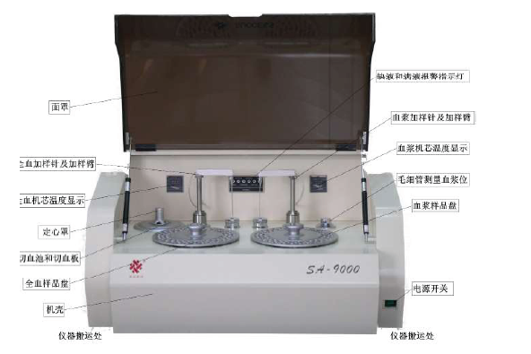
Fig. 1 Rheometer appearance
面罩 | Cover
全血加样针及加样臂 | Whole blood adding sample probe and sampling arm
全血机芯温度显示 | Whole blood movement temperature display
定心罩 | Centering cover
切血池与切血板 | Blood cutting pond/Blood cutting board
全血样品盘 | Whole blood sample plate
机壳 | Main case
仪器搬运处 | Instrument carrying area
仪器搬运处 | Instrument carrying area
电源开关 | Power switch
血浆样品盘 | Plasma sample disk
毛细管测量血浆位 | Capillary measuring plasma location
血浆机芯温度显示 | Plasma movement temperature display
血浆加样针及加样臂 | Plasma adding sample probe and sampling arm
When carrying instruments, it should move them from the bottom of both sides according to the Fig. above.
Note: The Fig. above takes SA-9000 as an example, from the appearance of SA-7000 and SA-9000, the difference lies in the instrument model and turntable.

4-2 Washing components
After opening the side cover of instruments’ both ends by tools, there will have a group of washing components.
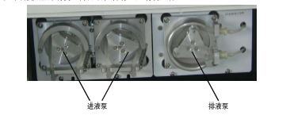
Fig. 2 Washing components
进液泵 | Inflow pump
排液泵 | Outflow pump

4-3 Rheometer rear view
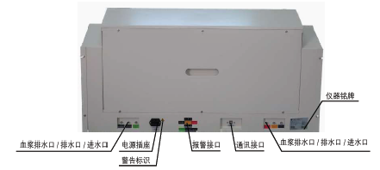
Fig. 3 Rheometer rear view
血浆排水口/排水口/进水口 | Plasma outfall/outflow/ inflow
电源插座 | Power socket
警告标识 | Warning label
通讯接口 | Communication interface
全血进水口1/进水口2/排水口 | Whole blood outfall 1/outflow 2/ inflow
仪器铭牌 | Instrument nameplate
Beside the power socket in front of the rheometer, there is a sign , which signifies that there has fuse protector small box under the power socket. Inside the small box, there are two fuse protectors with the manual of 3.15A (F ф5×20mm). When overload happens, the fuse protector blows and it is necessary to change the fuse protector. This fuse protector can be changed by the operator himself. When changing, power must be turned off. Pull out the small box and change 3.15A fuse protector. When changing the fuse protector by oneself, the operator must be careful!

4-4 Annex
4-4.1 Signal line
● Socket location refers to 5-2 instrument connection.
4-2.2 Random file
● Instrument packing list: After opening the box, the user shall check the internal box articles according to this list;
● Instrument certification: After instruments are qualified by the strict delivery detection of Succeeder’s Quality Inspection Department, it shall be issued with qualifications;
● Instrument guarantee card: As the receipt to prove the term of maintenance for instruments, users should read the information on it carefully and keep it properly;
● User operational flow card: Used for regulating user’s operation, the user should use the instrument according to the operating steps and attentions of this card;
● Customer installation training receipt: Customers’ approval proves for the integrity and completeness of instruments and training effects;
● The manual: It is the combination of operation manual for SA-7000 fully automated blood rheology analyzer/ SA-9000 fully automated blood rheology analyzer and the technical instruction.

5. Instrument Installation and Connection (The following operation explanations are taken SA-9000 as the example)

5-1 Installation place
5-1.1 The place where the room temperature is (10~30) ℃, avoiding direct sunlight, super cooling, superheating, or moist, and having air-condition inside the room generally.
5-1.2 The operating floor should be as steady and firm as possible, avoiding shaking.
5-1.3 Rheometer nearby has no strong electromagnetic interference, no violent vibration and no corrosive gas.
5-1.4 Rheometer has neither corrosive nor toxic gas, therefore, it has no special requirements for ventilation, either.

5-2 Instruments connection
Note: For the concerning interface location and name in this chapter, please refer to the contents and figures of the instrument appearance and marks manual.
5-2.1 Connect the computer main, displayer, keyboard, mouse, printer and power.
5-2.2 Connect the power line to the rheometer power socket.
5-2.3 Connect one end of USB cable to the rheometer communication interface and connect the other end to the computer USB interface.
5-2.4 Connect six silicone tubes of 2×5 respectively to the six water nozzles behind the instrument.
5-2.5 Insert the water pipe behind instrument marked with “capillary cleaning fluid” into the bucket marked with “capillary dedicated cleaning fluid”, insert the water pipe behind instrument marked with “hemorheology cleaning fluid” into the bucket marked with “rheometer special cleaning fluid-SAW, and insert the water pipe marked with “adding sample probe cleaning fluid” into the bucket marked with “adding sample probe cleaning and maintenance fluid-SAWZ”.
5-2.6 Insert the water pipe behind instrument marked with “cone-plate liquid waste”, “adding sample probe liquid waste” and “capillary liquid waste” respectively into the waste liquor bucket.
5-2.7 Insert the liquid level alarm device of three cleaning fluid buckets and three liquid waste buckets into the liquid level alarm port behind instrument respectively according to relative marks.
5-2.8 In case of being equipped with dynamic ESR/HCT analyzer, please connect one end of USB cable to the RS232 interface of dynamic ESR/HCT analyzer, and connect the other end to the computer serial port.
Note: When connecting instruments, please turn off the computer and instrument power, or it might damage the computer or instrument.

5-3 Access/Exit test program
5-3.1 Rheometer starting up
Turn on the rheometer power switch, and the instrument temperature controller will display the initial temperature. After the temperature is constant at 37℃, namely, the sample test can start.
5-3.2 Access test program
Turn on the computer power to access to Windows operating desktop. Double click the icon and enter into SA-9000 fully automated hemorheology testing software. According to the requirements of “Login” interface, choose the registered “Username” and input “Password”. After that, click the button “OK” and access to the testing software [main interface] (see Fig. 4).
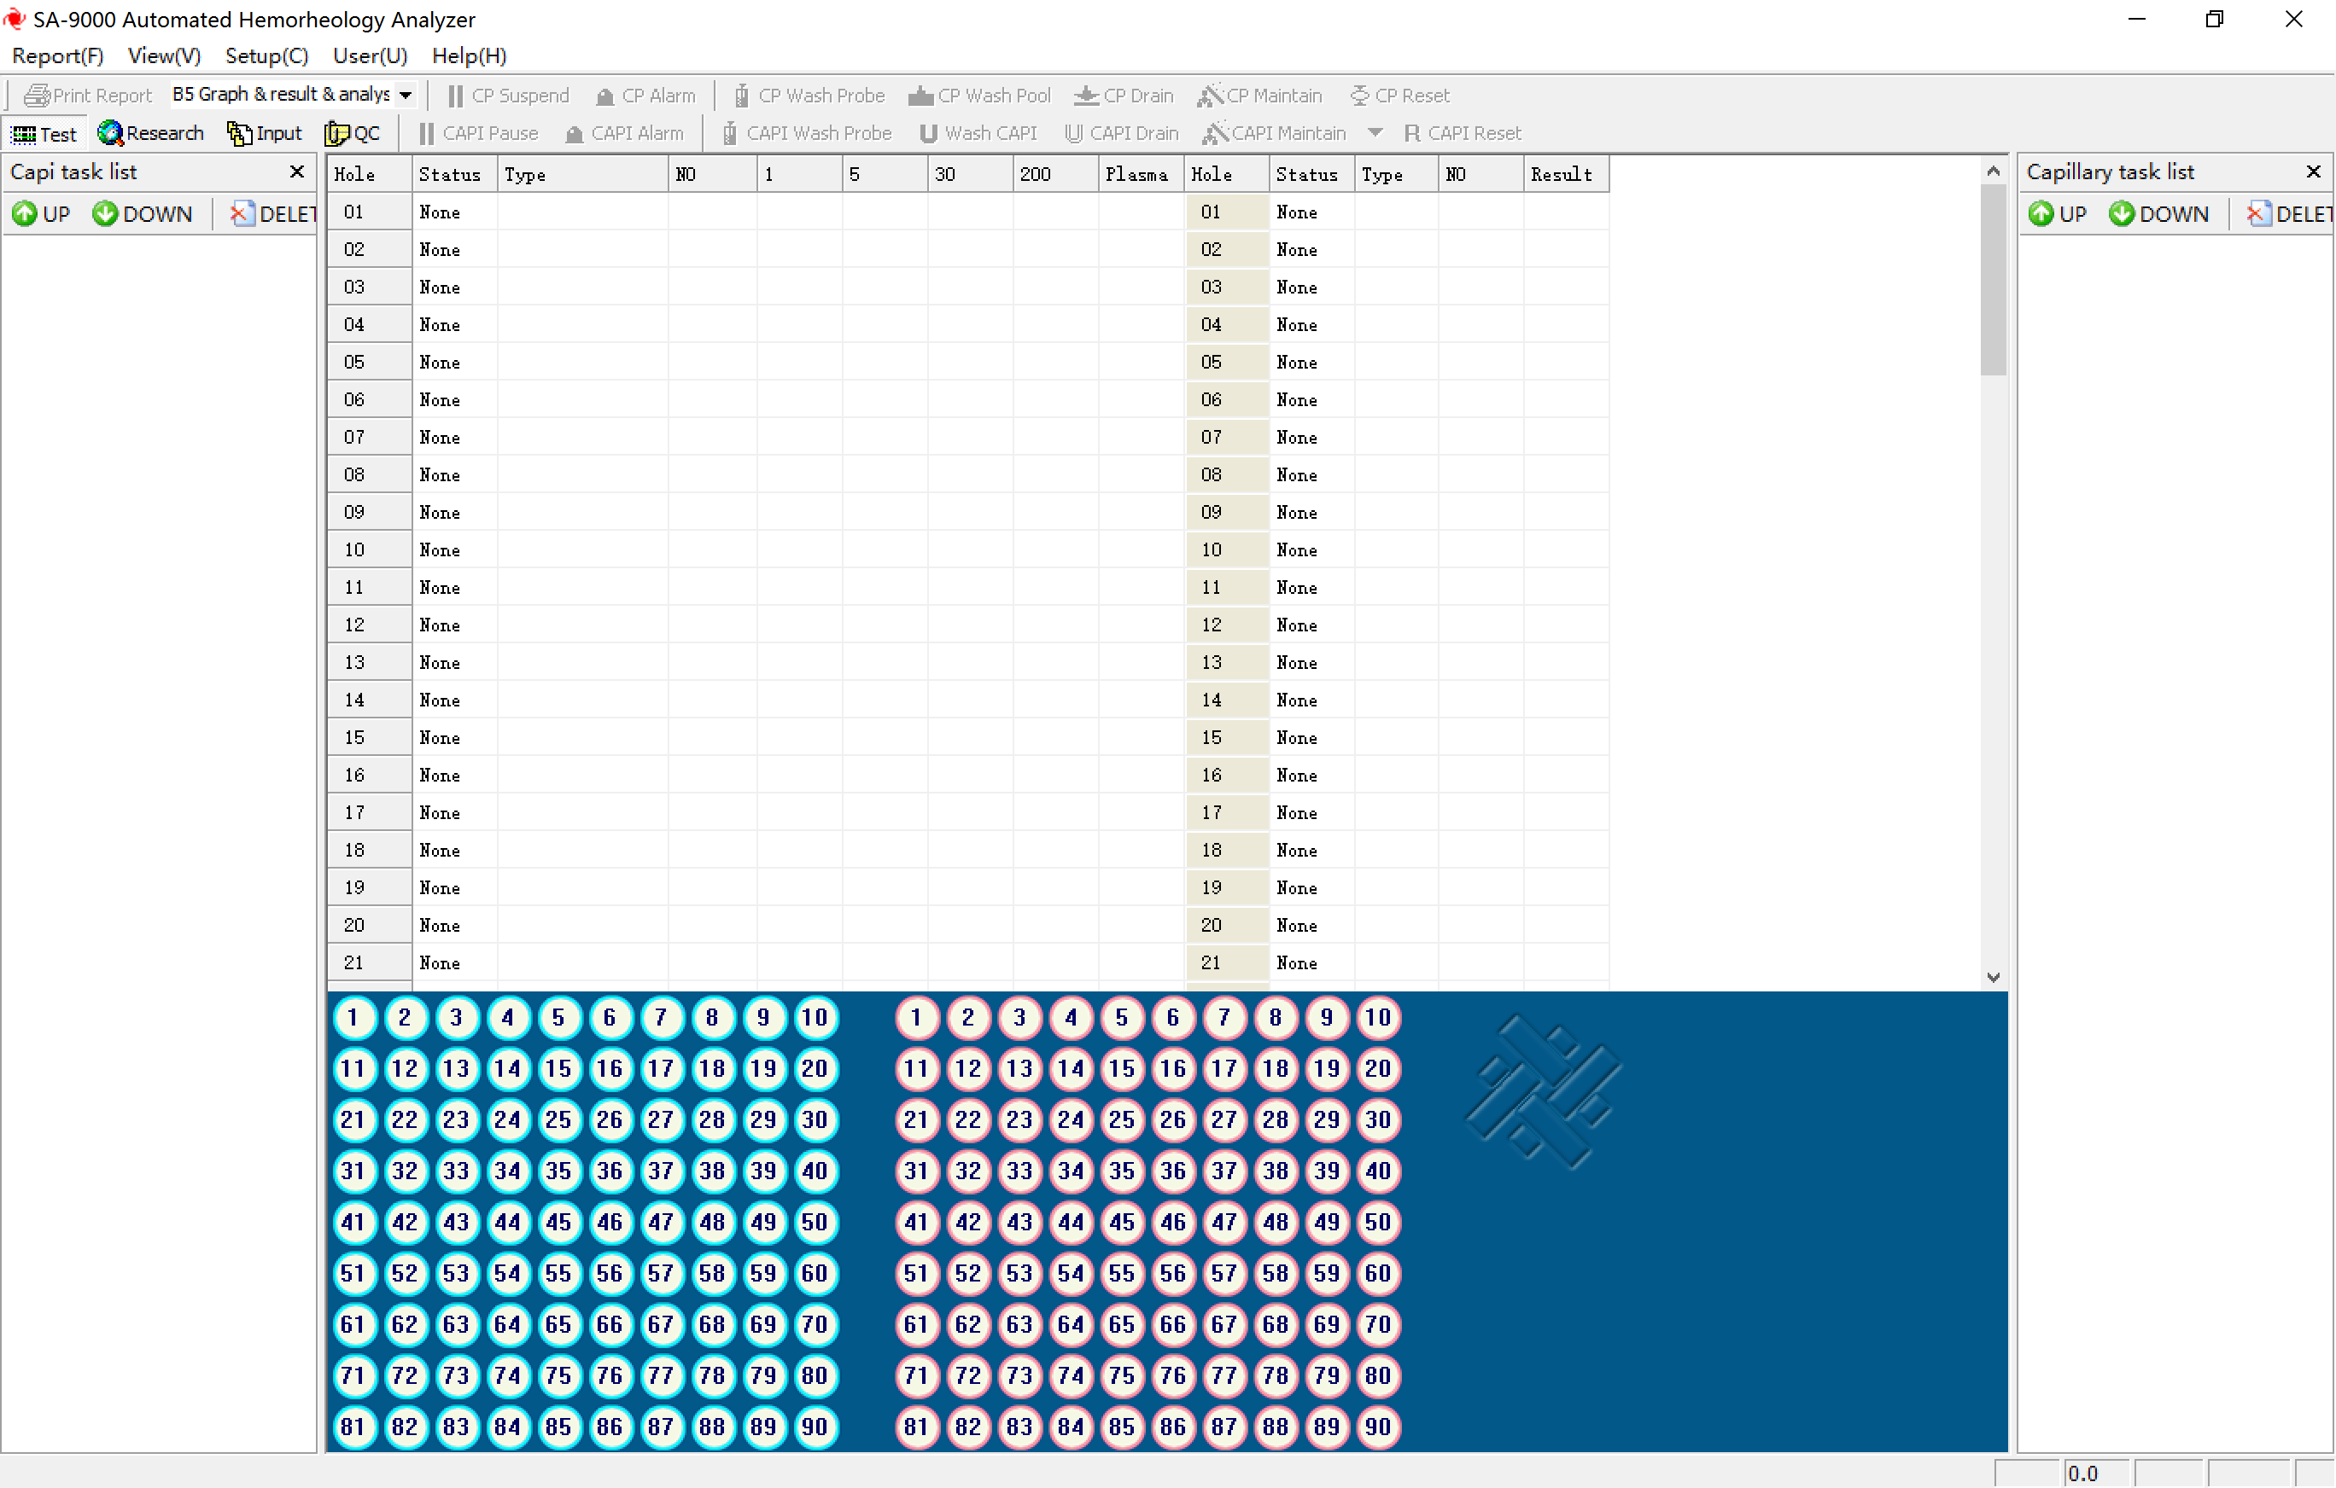
Test/Search
Test and display
Status bar
Adjustment bar
Test item setting
Tool bar
Menu bar
Fig. 4 Main interface
5-3.3 [Main interface] overview
5-3.3.1 [Report]: including the options of “edit style”, “printing”, “daily report”, “monthly report”, “self-defined report”, “statistics” and “exit”.
5-3.3.2 [Check]: including the options of “tool bar”, “status bar”, “test”, search”, “entry” and quality control”.
5-3.3.3 [Setting]: including the options of “cone-plate calibration” (available to add, delete, and modify samples as well as have system detection options), “capillary calibration”, “system detection”, “manual test”, “non-Newton quality control”, “user profile”, “external instrument”, “network”, “capillary options”, “normal value”, “alarm limit”, “shear rate”, “test item”, “storeroom”, and “analysis report”.
5-3.3.4 [User]: including “login”, “logout”, “management” and “change password”.
5-3.3.5 [Help]: including the options of “about” and “show”.
5-3.3.6 [Main interface] composition:
a) Test/search window: display task list, set search condition and display search results;
b) Test display area: display test status, sample type, and whole blood and plasma viscosity test results;
c) Test item setting area: set test item and display test status; the numbers 1～90 in sample icons will correspond to the hole site number of sample disk;
d) Menu bar: including all available orders of the current window. The menu bar displays the main menu of pull-down menu. Click its menu options and the screen will display the pull-down menu of this menu options. And the pull-down menu options are the available orders for users;
e) Tool bar: display some common orders that users often use on the tool bar in “order button” form;
f) Status bar: Window bottom is used for providing relevant information of current window. Via [Check] menu item in menu bar, control the tool bar and status bar whether or not to be shown in the screen will be realized;
h) Adjustment item: drag the adjustment item around by mouse can change the size of relative display areas, so that it will be convenient for checking more contents.
5-3.4 Exit test program
In the [Main interface] (see Fig. 4), click top right corner button “×” or the menu item “exit” in [Report] both can exit the test program. After exiting the test program, turn off the rheometer power.

6. Menu operation

6-1 [Report] item operation
Click [Report] item in the [Main interface] (see Fig.4), it will display the pull-down menu under it, including the options of “edit style”, “printing”, “daily report”, “monthly report”, “self-defined report”, “statistics”, and “exit”. There are lower class submenus under the “edit style” menu, including “new”, and test report style with software, which are provided for users to choose.
6-1.1 “Edit style” menu item operation
Click “Edit style” menu item, it will show its lower class submenus. Click the submenus and enter into relevant function operation interface. “Edit style” menu item is mainly used for new, modify “test report” item and format, whose contents can be referred to the test report design.
6-1.2 “Print” menu item operation
After select test report of patient needs printing, click “print” menu item and enter into [Print interface] (see Fig. 5). It can set the items of printer, printing range, copies, layout, and paper/quality, etc. in accordance with the actual situation. After setting all items, click button “OK” , and the printer prints the selected “test report”.
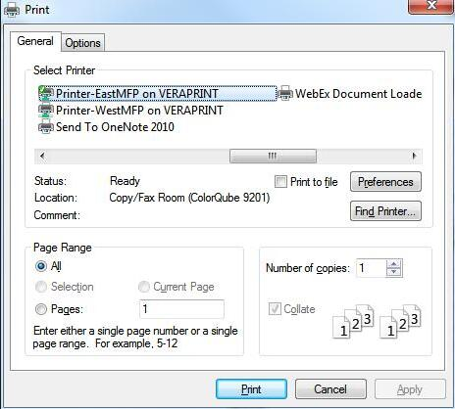
Fig. 5 Printing interface
6-1.3 “Daily report”, “monthly report” and “self-defined report” menu item operation
Click relevant menu item and enter into the corresponding report setting interface. According to the actual needs, set the starting and ending time. Then, click button “OK” to enter into [Printing interface] (see Fig.5), and print “test report”.
6-1.4 “Statistics” menu item operation
Click “statistics” menu item and enter into [Statistics interface] (see Fig. 6). The statistics types include: normal value, sample quantity and disease entities. After select different statistics types and statistics areas, click button “statistics”. The computer will design automatically according to the setting condition and display statistics report. Users can have various word processing operations for the statistics report file.
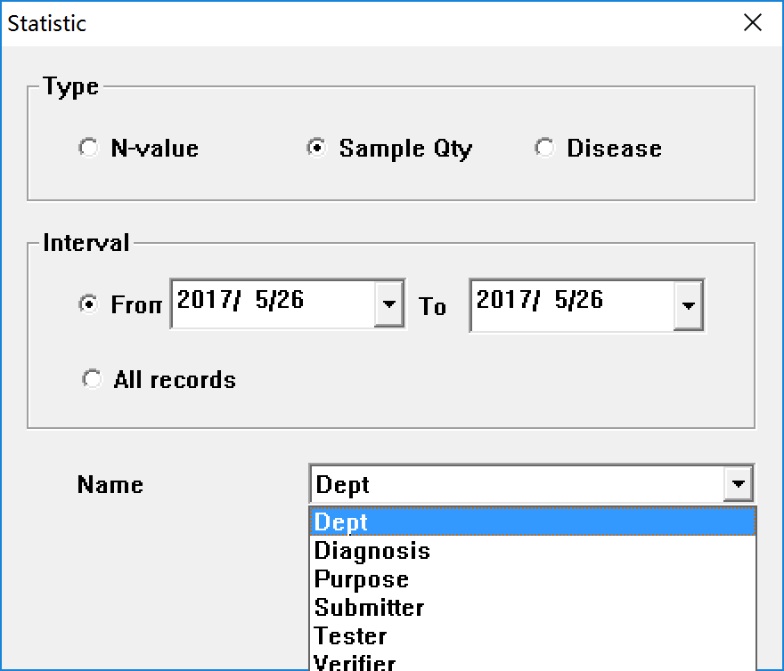
Fig. 6 Statistics interface
6-1.5 “Exit” menu item operation
Click “exit” menu item and exit the test program; click button “×” at the top right corner of [Main interface] (see Fig. 4) also can exit the test program.

6-2 [Check] item operation
Click [check] item in the [Main interface] (see Fig. 4), and it will display its lower class submenus, which include the options of “tool bar”, “status bar”, “test”, search”, “entry” and “quality control”.
6-2.1 “Tool bar” menu item operation
Click “tool bar” menu item in the [Check] item and the [Main interface] (see Fig. 4) menu bar below displays the tool bar.
CP | Cone plate (CP)
CAPI | Capillary (CAPI)
Click the “tool bar” menu item again and hide the tool bar.
a) Click“▼”, it can select test report style in the pull-down list. Click button “printing”, it can print the test report according to the selected test report style;
b) Click buttons of “test”, “search”, “entry”, and “quality control”, it can switch among test window, search window, entry window and non-Newton quality control diagram interfaces;
c) When clicking the button “cone-plate pause”, it will cease the current whole blood test. When clicking that button again, it will recover to the current test;
d) If the sample whole blood testing results exceed the alarm limit, instrument will alarmautomatically; at the moment, if clicking the button “cone-plate alarm confirm”, the alarming sound will cease;
e) When clicking the button “cone-plate cleaning needle”, instrument will automatically clean the whole blood adding sample probe;
f) When clicking the button “cone-plate cleaning”, instrument will automatically clean the liquid pool;
g) When clicking the button “cone-plate draining”, instrument will automatically drain the liquid in the pool;
h) When clicking the button “cone-plate maintenance”, instruments will clean the whole blood adding sample probe for once and the liquid pool for three times in accordance with the setting program. It is suggested that after the end of test for all samples every day, use this button for instrument maintenance.
i) When clicking the button “capillary pause”, the current plasma test will be ceased. When clicking it again, the current test will be recovered;
j) If the sample plasma testing results exceed the alarm limit, instrument will automatically alarm; at the moment, click the button “capillary alarm confirm”, the alarming sound will stop;
k) When clicking the button “capillary cleaning needle”, instrument will automatically clean the plasma adding sample probe;
l) When clicking the button “cleaning capillary”, instrument will automatically clean the capillary;
m) When clicking the button “capillary drain”, instrument will automatically drain the capillary liquid;
n) When clicking the button “capillary maintenance”, instrument will clean the whole blood adding sample probe for once and the capillary for three times according to the setting program. It is suggested that before the test for all samples every day, use this button for instrument maintenance.
6-2.2 “Status bar” menu item operation
When clicking “status bar” menu item, the status bar will display below the [Main interface] (see Fig. 4). When the mouse stays at different function buttons of the tool bar, the status bar will display the working status for relevant buttons. When clicking the “status bar” menu item, the status bar will be hid.
6-2.3 “Test” menu item operation
When clicking “test” menu item, “test window” will be displayed in the left side of screen, refer to 7-6 for “test” menu item operation;
6-2.4 “Search” menu item operation
When clicking “search” item, the “search window” will be displayed in the left side of screen. Then, refer to 7-7 for “search” menu item operation.
6-2.5 “Entry” menu operation
Click “entry” menu, and switch to [entry interface] (see Fig. 12). Please refer to VIII-4 batched entry of patients’ information for operation.
6-2.6 “QC” menu operation
Click “entry” menu, and switch to [non-Newtonian QC chart interface] (see Fig. 7). Conduct non-Newtonian QC and save QC results of the day in accordance with IX-4 “non-Newtonian QC” menu operation on a daily basis. The following contents can be displayed in this interface:
a) Select “non-Newtonian low shear” and “non-Newtonian high shear” in “QC items” on the left of the interface, then the low shear and high shear QC charts and test data will be displayed on the right of the interface;
b) Fill in “mean value” and “SD” in “item attribute” in accordance with nominal values of non-Newtonian low shear or high shear viscosity and corresponding SD values, and click “save parameters” button to save the aforesaid data;
c) If the QC result of the day exceeds +2SD, red marks will be displayed in the chart. Then, it needs to find causes of QC abnormality, and the patient sample test cannot be made till the QC result is controlled within +2SD;
d) The following “data list” can display the corresponding quality control time and data for the quality control diagram; if the numerical value exceeds ±2SD, the quality control data and the data will display red;
e) It is available to select the starting and ending time in accordance with demands. When clicking the button “calculation”, instrument will automatically calculate quality control data for selected period, with calculation results displayed in the “quality control item properties”, including average value and SD (standard deviation), and analyze quality control trends;
f) It is available to delete former quality control data;
g) Lay the mouse to an optional position in the quality control diagram coordinate system; when pressing the left mouse button and dragging the mouse to left or right at the same time, and quality control diagrams of different months and dates will be displayed;
h) After selecting the test month and date in the right interface, when clicking “printing” menu item or the icon (Print) in the tool bar, it will print the selected quality control diagram.
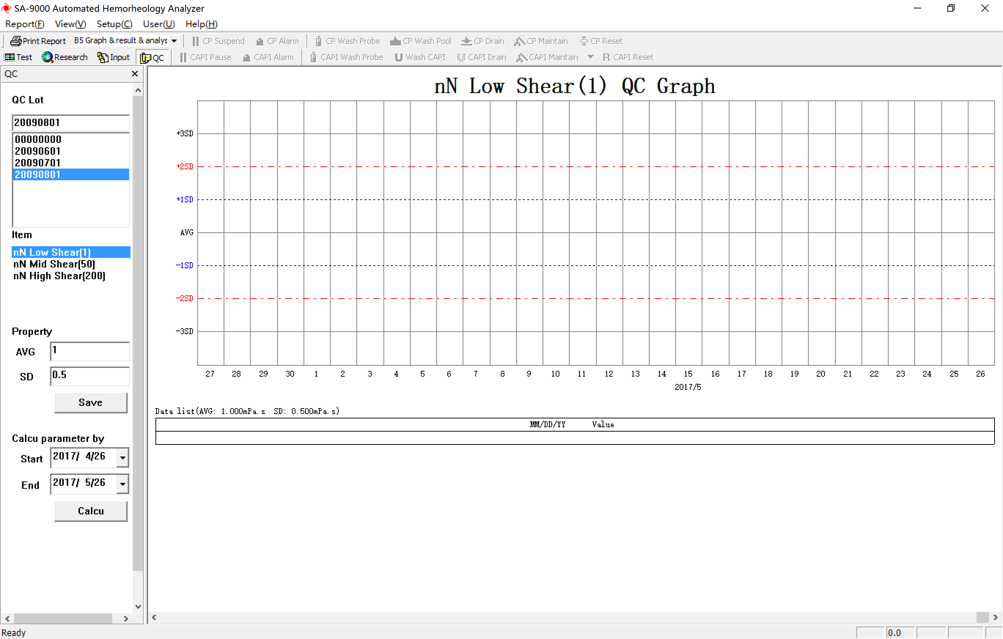

Fig. 7 Non-Newton quality control diagram interface
Shear | shear rate
nN | Non-Newton

6-3 [Setting] item operation
Via the operation to the lower-class submenus of [setting] item, complete the initial setting for corresponding information. Then,refer to [setting] item operations.

6-4 [User] item operation
When clicking [user] item in the [Main interface] (see Fig. 4), it will display its submenus, including the options of “login”, “logout” “management” and “change password”.
a) Click “login” menu item to access to the login interface; after choosing the login username and input the password, click button “OK”, and the user will access to the test software system regarded as the operator;
b) Click “logout” menu item and popup the login interface, it can logout current username and re-login;
c) Click “management” menu item to access to the management interface, it can add or delete the user having registered and realize the management for operating personnel;
d) Click “change password” menu item to access to change password interface, it can alter the login password to guarantee the system safety.
6-5 [Help] item operation
When clicking [help] item in the [Main interface] (see Fig. 4), it will display its lower class submenus, including the options of “about”, “cone-plate display”, “capillary display” and “simultaneous display”.
a) When clicking “about”, it will display [about interface] (see Fig. 8) and be available to check software name, edition and other information; when clicking button “OK” or “×”, the interface will be closed;
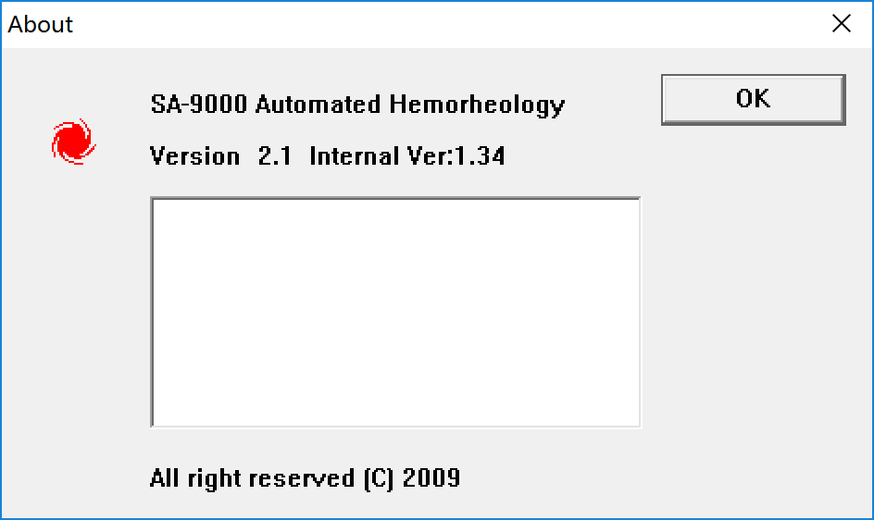
Fig. 8 About interface
b) When clicking “cone-plate display” menu item, instrument will respectively display the actions of rotating form the sample disk to the starting position, adding sample probe locating, and absorbing from left side sample disk test tube hole I automatically, as well as OK the accuracy of the whole progress adding sample probe actions;
c) When clicking capillary display” menu item, instrument will respectively display the actions of rotating form the sample disk to the starting position, adding sample probe locating, and absorbing from left side sample disk test tube hole I automatically, as well as confirm the accuracy of the whole progress adding sample probe actions;
d) When clicking “simultaneous display” menu item, instrument will respectively display the actions of rotating form the sample disk to the starting position, adding sample probe locating, and absorbing from left side sample disk test tube hole I automatically, as well as confirm the accuracy of the whole progress adding sample probe actions.

7. Test operation
Fig. 9 is the [Test interface] serving as the reference for this chapter.
Fig. 9 Test interface

7-1 Pre-test preparation
7-1.1 The rheometer can only be used in the test after calibration (calibrate the instrument according to relevant content of 8-1 “calibration” menu item operation.
7-1.2 Prepare the whole blood sample and blood plasma sample according to relevant content of 10 sample collection and preparation.
7-1.3 Insert the tubes with sample in the tube holes of the specimen disc according to the sorting number (serial number).
☆ Notice: 1. Every sample tube of the same day must have one and only one sorting number (serial number). The serial number in the basic information area of the sample in the sample hole of the specimen disc must be the same as the sorting number of the sample tube in this hole.
2. The whole blood tube sorting number and blood plasma tube sorting number must be the same.

7-2 Batch test
In “test item setting area” of the [Test interface] (see Fig. 9) , choose one sample location icon on the left, right-click, the [Test options interface] (see Fig.10) will appear, including four options: “whole blood test”, “batch input”, “cancel test” and “batch cancel”; choose one sample location icon on the right, right-click, the [Test options interface] (see Fig.10) will appear, including four options: “blood plasma test”, “batch input”, “cancel test” and “batch cancel”

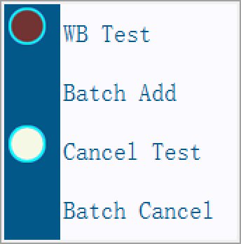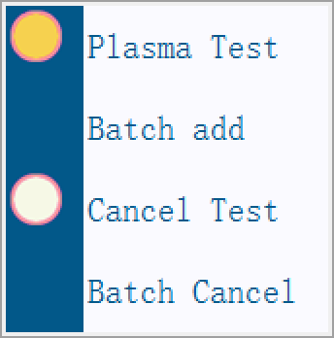
Fig. 10 Test options interface
WB | Whole blood (WB)

7-2.1 Click on the “batch input” to enter [Batch input interface] (see Fig.11).
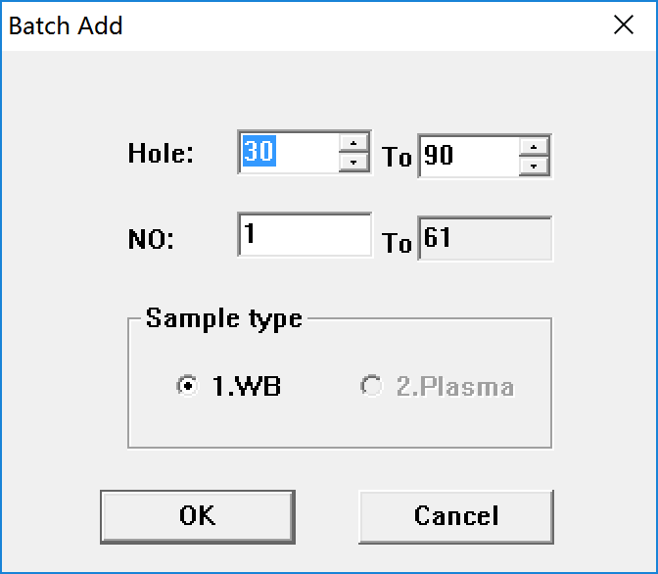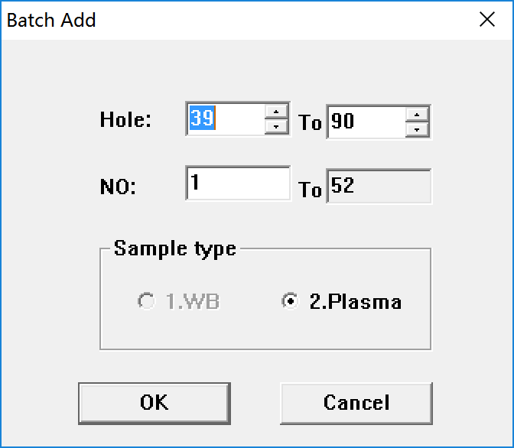
Fig.11 Batch input interface
7-2.2 Fill in the starting hole number and terminating hole number according to the tube hole number in the specimen disc. The starting hole number and terminating hole number can be input from keyboard, or set by pressing the UP ARROW and DOWN ARROW in 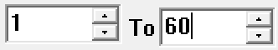.
7-2.3 After setting hole number, fill in the starting serial number according to the sample tube sorting number, and the starting number can only be input from keyboard; the computer will automatically give out the terminating number.
7-2.4 Set program default sample type. Enable batch test default on the left as “whole blood”, and enable batch test default on the right as “blood plasma”.
7-2.5 click on the “OK” button, the instrument will carry on continuous test in order.
7-2.6 Sample location display status description:
7-2.6.1 If the icon of the sample location having been set turns brownish red, that means the corresponding sample is waiting for test (like , make whole blood test of the sample in this sample location) , if it turns yellow, that means (like, make blood plasma test of the sample in this sample location) ; the sample locations have not been set, their icon are white ( like: this sample location is in idle state).
7-2.6.2 Rank the sample location having been set in the task list of the “test window” in testing order.
7-2.6.3 If the sample location icon flickers constantly, that means the sample in this sample location is being tested.
7-2.6.4 If the sample location icon turns gray, (like , that means the sample test of this sample location is completed.
7-2.6.5 Pitch on the sample location icon having being set, right-click, the [Test options interface] (see Fig.10) will appear, click on the “test cancel”, then the sample test of this sample location is cancelled), meanwhile, the corresponding hole number in the task list of the “test window” will disappear.
☆ Notice: The test of the sample being tested and the next sample under blending cannot be cancelled.
7-2.7 Pitch on any sample location icon, right-click, the [Test options interface] (see Fig.10) will appear, click on the “batch cancel” to enter batch cancel interface, choose the starting hole number and terminating number, then the sample test of corresponding hole will be cancelled.

7-3 Single sample hole test
Click sample location icon of the sample tube in the “test item setting area”, the [Test options interface] (Fig.10) will appear, according to the sample type, click “whole blood test” or “blood plasma test”, then the instrument starts to test. In case that, before setting the single sample test, the sample is already in the task list, then the sample will be tested in the task list order.

7-4 Batch entry of patients’ information
After the instrument starts to test, input the patient information. Click on the button in the toolbar, enter the [Input interface] (see Fig.12) , patients basic information input sheet will appear in the page, the sheet content includes: serial number, name, gender, age, medicinal classification, inpatient area, medical record No., bed number, clinical diagnosis, submitting physician, testing physician, verification physician, testing purpose, erythrocyte sedimentation rate, and hematocrit of red cells, input the relevant items according to real content.
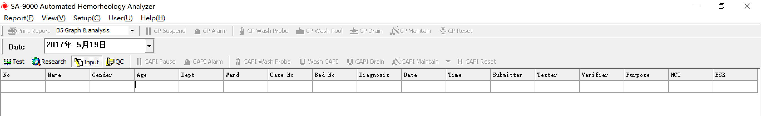
Fig.12 Entry interface

7-5 Test procedure
7-5.1 When the test item setting is completed, the adding sample probe will turn to the test hole of the specimen disc, and mix the sample for three times.
7-5.2 Sucks up the sample, the adding sample probe will turn to the test location, and pour the sample in the liquid pool, and then the test starts.
7-5.3 The adding sample probe returns to the cleaning location, and the instruments will clean the adding sample probe automatically.
7-5.4 The adding sample probe returns to the tube hole of ne9t sorting specimen disc and waits for ne9t test.
7-5.5 Sample test finished, the instruments cleans the liquid pool automatically, after cleaning, the rheometer starts to test next sample automatically.

7-6 “Test” menu item operation
Click on the (Test) button in the toolbar or click on the “test” menu item of the [View] Item, the “test window” (see Fig. 13) will appear. Click on the button again or click on the “×”button of the “test window” to close this window.
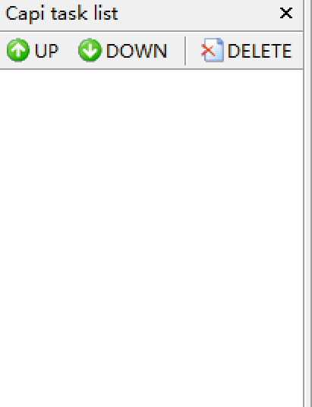
Fig. 13 Test window
7-6.1 Display the task list in the test window, the numbers after “孔” (“hole”) shall be the same as the sample location icon numbers in the “test item setting area”; The number in bracket is the sorting number of the sample tube.
7-6.2 Move the mouse on one hole number of the task list, left-click on the to pitch on this test location, and a blue cover strip will appear on this test location, in this occasion, every time you click on the button or  button, the test sequence of this sample location will be brought forward or given back one order. The test sequence can also be changed by moving up or down the mouse while pitch on the hole number. Test of emergency treatment sample can be achieved by changing the test sequence.
7-6.3 Move the mouse on one hole number of the task list, pitch on the test location, a blue cover strip will appear, click on the “”(Delete) to cancel the test of the sample location, meanwhile, the corresponding sample location icon in the “test item area” will turn white, and this sample location returns to idle state.

7-7 “Search” menu item operation
Click on the “” button in the toolbar or click on the “search” menu item of the [View] item, the “search window” will appear (see Fig. 14). Click on the button again or click on the “×” button of the “search window” to close this window.
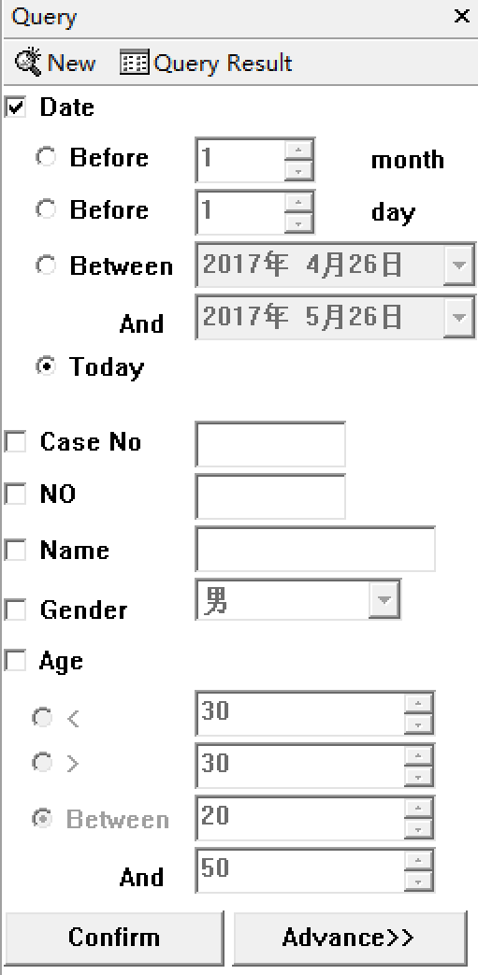
Fig. 14 Search window
7-7.1 Set search condition according to the actual statistics demand, and the search conditions include: date, medical record No, serial number, name, gender, and age. You can make free combination of the conditions above. When the search conditions are confirmed, click on the button, then the eligible searching result list will appear.
7-7.2 Click on the  button to reset the search condition.
7-7.3 Click on the “” button, the searching result list of the former search condition will reveal.
7-7.4 Click on the “” button, to carry on advanced composition condition search, advanced search can be carried on by choosing search condition in the dropdown list.

7-8 Test result display
Fig. 15 is the referential [Test result display interface] of this chapter.
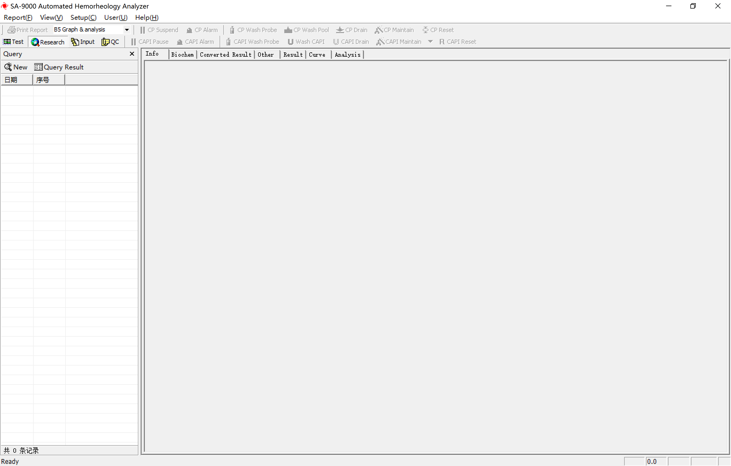
Fig. 15 is the referential [Test result display interface] for this chapter.
When the sample test is completed, use the search function(see the search function in 7-7 “search” menu item operation), choose the serial number of the patient, in the right part of the [Test result display interface] (see Fig. 15), the relevant patient information buttons will reveal in sequence, including “basic information”, “test result”, “conversion result”, “other result”, “curve”, and “result analysis”. Click on the relevant button, this data array item sheet will reveal in the interface.
7-8.1 “Basic information” item sheet is made by manual input,, see this operation in 7-4 Batch entry of patients’ information; modification can also be made on this basic information item sheet in this interface.
7-8.2 “Test result” item sheet content will display automatically. If the sample only took “whole blood test”, then the sheet will display the whole blood viscosity under the preset shear rate; the user can voluntarily set the shear rate according to the need. See shear rate setting in 8-11“shear rate” menu item operation.
— If the sample only took “blood plasma test”, then the sheet only displays plasma viscosity.
— If the instrument is connected with external instruments (see 8-6 external instrument” menu item operation), then the erythrocyte sedimentation rate and hematocrit of red cells test result will be transmitted to the “test result” item sheet automatically.
7-8.3 The content of “conversion result” item sheet is the conversion results, and the conversion results generate automatically and directly display in the item sheet.
☆ Notice: 1. If these is no erythrocyte sedimentation rate test result, and then there is no way to convert K Value of the erythrocyte sedimentation equation.
2. If these is no hematocrit test result, these is no way to convert K Value of the erythrocyte sedimentation equation, whole blood reduction viscosity, erythrocyte rigidity inde9, and erythrocyte deformation inde9 TK.
7-8.4 “Chemical result” item form contents are made by manual input; the user input the data according to the patient’s relevant test results.
7-8.5 “Other results” item sheet is made by manual input; the user enters the data according to the patient’s relevant test results.
7-8.6 “Result analysis” reveals the evaluating conclusion of the whole sample test procedure, and is used for improve reliability of the users’ evaluation of the test result.

7-9 Viscosity - shear rate curve
Click on the “curve” button in the [Test result display interface] (see Fig. 15), the [Curve display interface] (see Fig. 16) will appear. In the shear rate – viscosity 2d coordinates, the green curve is the whole blood or blood plasma viscosity curve, the white vertical line is the shear rate selection wire. By choosing different shear rates, observe the viscosity number of the measured sample under different shear rate.
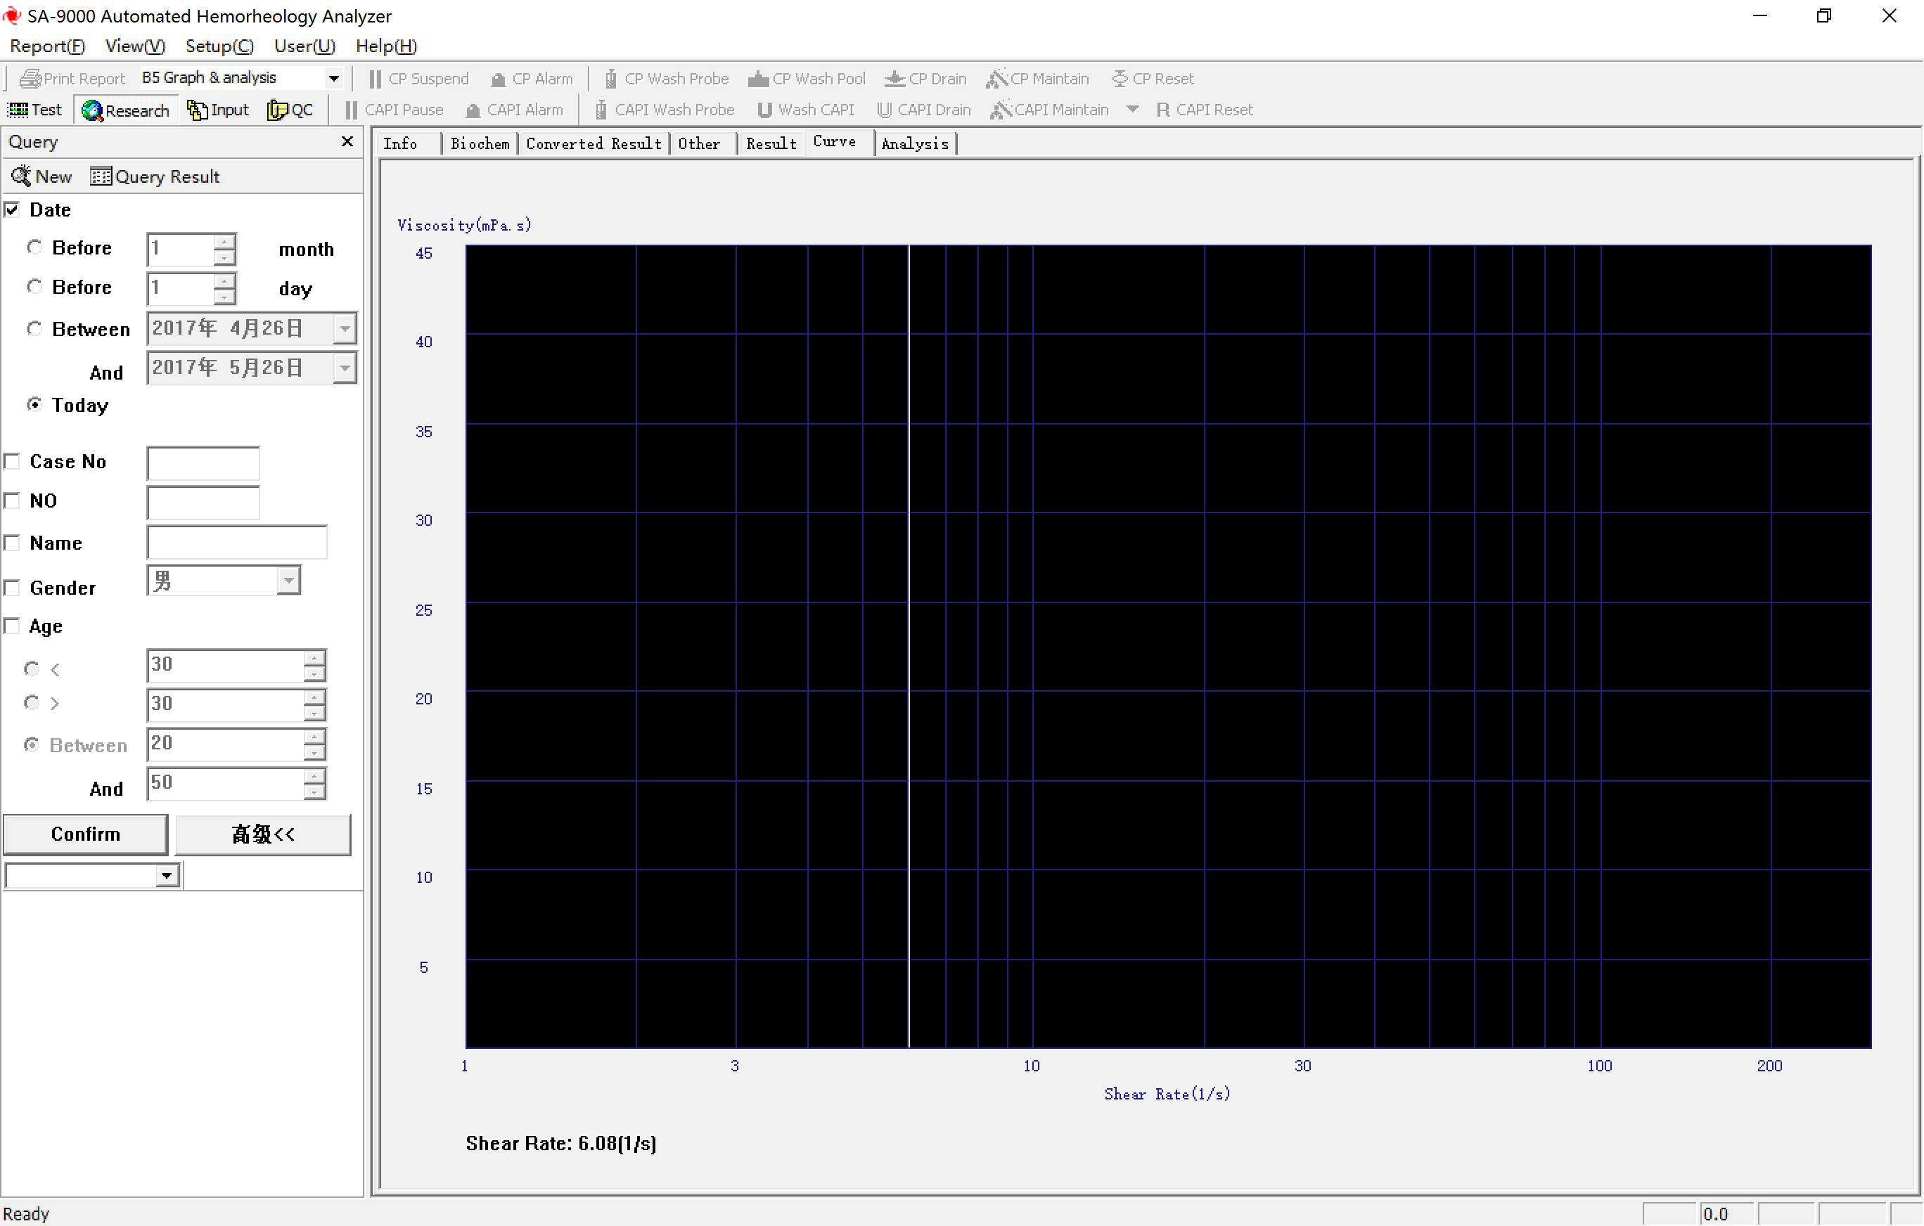
Fig. 6 Curve display interface

7-9.1 Drag the white shear rate selection wire by mouse, the shear rates and corresponding viscosity numbers will reveal in the bottom of the diagram.
7-9.2 Dragging the white shear rate selection wire by mouse while pressing “shift” button can select any one of twenty integer shear rates set by the software( (1s⁻¹、2s⁻¹、3s⁻¹、4s⁻¹、5s⁻¹、6s⁻¹、7s⁻¹、8s⁻¹、9s⁻¹、10s⁻¹、20s⁻¹、30s⁻¹、40s⁻¹、50s⁻¹、60s⁻¹ 、70s⁻¹、80s⁻¹、90s⁻¹、100s⁻¹、200s⁻¹) , the shear rate and corresponding viscosity number will reveal in the bottom of the diagram.

8 [Set] item operation
Click on the [set] in the [Test interface] (see Fig. 9), the submenu of this option will appear, including “cone-plate calibration”, “capillary calibration”, “system detection”, “manual test”, “Non-Newtonian quality control”, “user information”, “external instruments”, “network”, “cone-plate options”, “capillary options”, “normal value”, “alarm limit”, “shear rate”, “test items”, “library”, and “analysis report”. Thereinto, the font color of “cone-plate options” and “capillary options” is gray. This function is not available for user, only used by the technicians of authorized manufacturers, if any problems in this area come out, please contact with Succeeder and the franchiser.

8-1 “Cone-plate calibration” menu item operation
Click on the “cone-plate calibration” menu item, the [Calibration interface] (see Fig. 17) will appear, there are four options in the “cone-plate calibration” menu item, separately are “add standard sample”, “delete standard sample”, “modify standard sample” and “clean liquid pool”. After completing the calibration operation, click on the “OK” button, then all the operation results will be preserved; click on the “cancel” button, then it will not preserve the operation results.
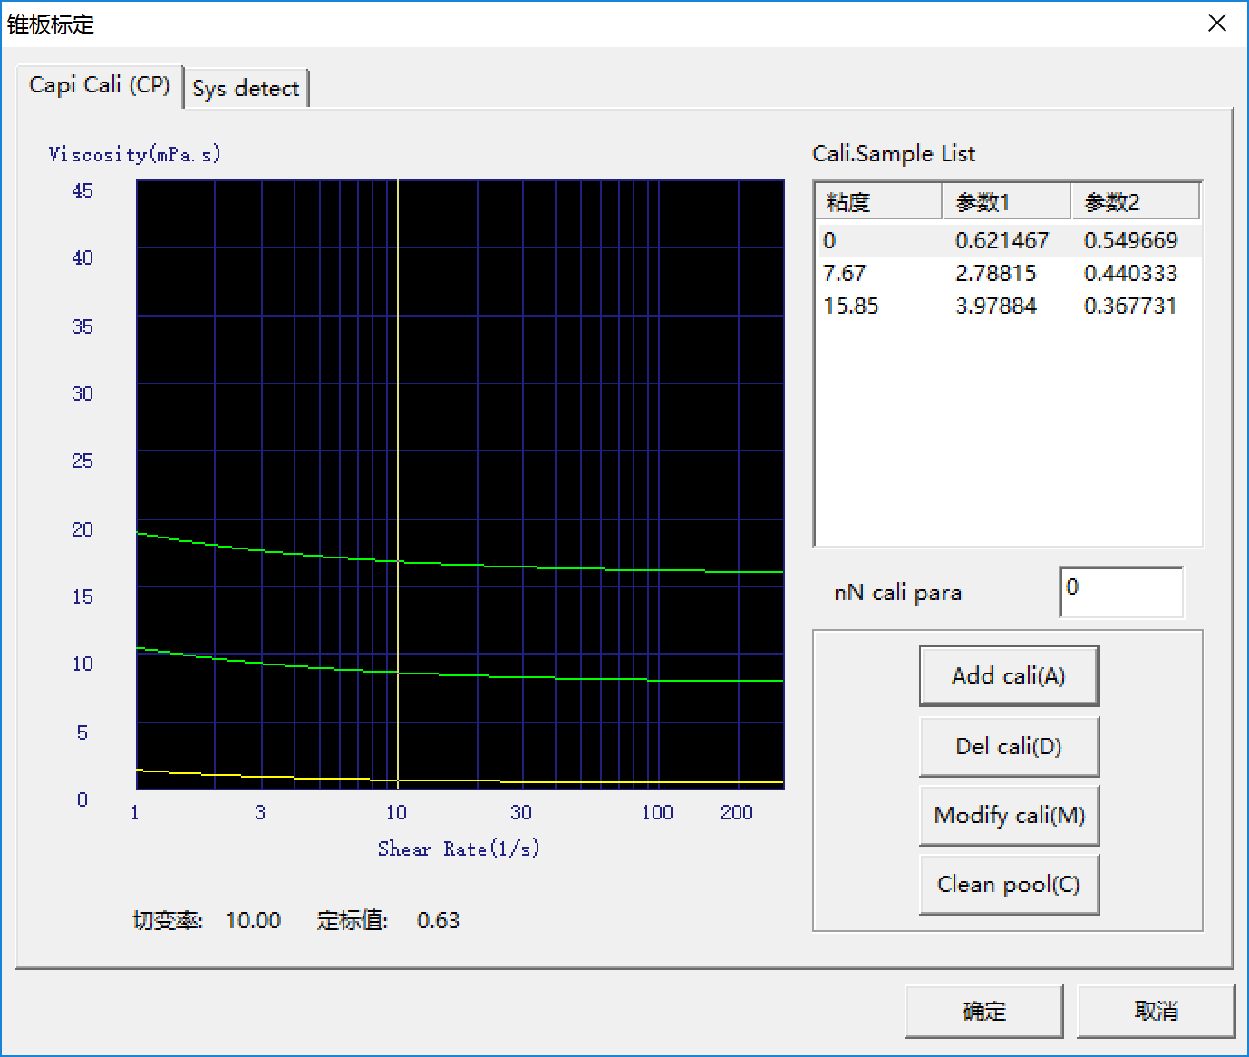
Fig. 17 Calibration interface
椎板标定 | Cone plate calibrate
参数 | parameter
切变率 / 定标值 | Shear rate / calibration value
确定 / 取消 | OK / Cancel

8-1.1 Add standard sample
8-1.1.1 Zero calibration: add no liquid in the liquid pool, click on the “add standard sample” button in the [Calibration interface] (see Fig. 17), a “Input Dialog” will appear, input the viscosity number: 0, and click on the “OK” button, then the instrument starts zero calibration test.
8-1.1.2 Standard viscosity liquid calibration: add 0.8ml standard viscosity liquid to the liquid pool with pipette, click on the “add standard sample” button in the [Calibration interface] (see Fig. 17), a “Input Dialog” will appear, input the viscosity number of standard viscosity liquid, and click on the “OK” button, then the instrument starts standard viscosity liquid calibration test.
8-1.1.3 After the calibration test, a green calibration curve will be shown in the Shear rate- Viscosity coordinate.
8-1.1.4 “Standard sample list” frame will display the viscosity, parameter 1 and parameter 2 of corresponding viscosity liquids for all calibration curves
8-1.2 Delete standard sample
8-1.2.1 Pitch on a set of horizontal data in the “standard sample list” frame, the data will be covered by a blue strip, and the corresponding curve in the Shear rate-Viscosity coordinate will turn yellow. Click on the button “delete standard sample”, then the calibration curve will disappear from the coordinate as well as the corresponding data in the “standard sample list” frame.
8-1.2.2 Keep the zero calibration curve, high viscosity (Eg: Under 37℃, the viscosity nominal value is around 27.0mPa•s) cabilation curve and low viscosity (Eg: Under 37℃, the viscosity nominal value is around 7.0 mPa•s) cabilation curve at least one for each, so as to guarantee the normal test of the rheometer.
8-1.3 Alter standard sample
Pitch on a set of horizontal data in the “standard sample list” frame, the data will be covered by a blue strip, and the corresponding curve in the shear rate-viscosity coordinate will turn yellow. Click on the button “alter standard sample”, a “input parameter” dialog box will appear. After inputting parameter 1 and parameter 2, click on the “OK” button. This operation can be used to alter the viscosity curve location and parameter values.
☆ Notice: The user shall not use “alter standard sample” operation without authorization, for fear of leading to inner parameters chaos of the instrument system and affecting the accuracy and precision.

8-2 “Capillary calibration” menu item operation
Click “Capillary calibration” menu item, the [Calibration interface] (see Fig. 18) will appear, the “calibration” menu item reveals the original calibration value, you can click on the “re-calibrate” to calibrate again. After the calibration operation is completed, click on the "Accept" button to preserve all the operation results; or click on the "Discard" button, then the operation results will not be preserved.
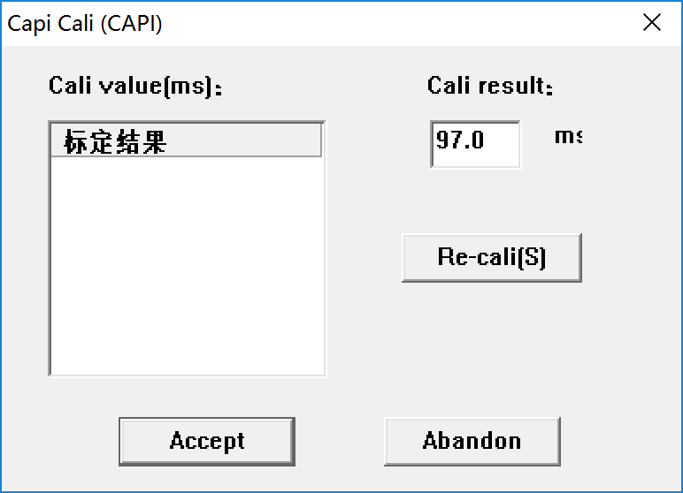
Fig. 18 Calibration interface
Capi cali | Capillary calibration
cali | Calibration
标定结果 | Calibration result

8-2.1 Put an empty tube in NO. 1 hole of the specimen disc on the right of the instrument and add 3ml distilled water in it, click on the “re-calibrate” button in the [Calibration interface] (see Fig. 18), a “prompt dialog box” will appear, click on the “OK” button, then the instrument starts capillary calibration test.
8-2.2 When the calibration is completed, three calibration results will reveal on the left, the current calibration value will reveal on the right, click on the “accept” button to preserve the new calibration value.
Note: Capillary calibration is necessary before every test.

8-3 “system detection” menu item operation
Click on the “system detection” menu item to enter the [System detection interface] (see Fig. 19). Test the same standard viscosity liquid for five times automatically, by this operation, to detect the instrument’s repeatability.

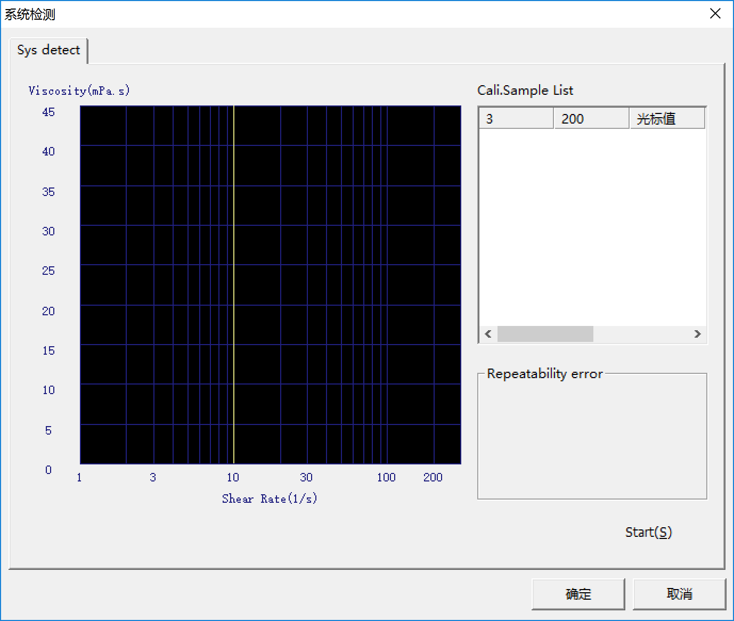
Fig. 19 System detection interface
系统检测 | System detection (sys detect)
光标值 | Cursor value
8-3.1 Add standard viscosity liquid in the liquid pool, and click on the “start” button, then the instrument starts to test. During the test, the system will remind the test schedule at all times. When the test is completed, five test curves almost coincide will appear in the shear rate- viscosity coordinate, the viscosity numbers correspond to the low shear rate 3.0s⁻¹) and high shear rate (200.0s⁻¹) of every test will display in the “sample list”.
8-3.2 Coefficient of variation (CV) of the viscosity numbers correspond to the low shear rate 3.0s⁻¹) and high shear rate (200.0s⁻¹) will be displayed in the “repeatability error” box.
8-3.3 By dragging the shear rate selection wire to observe different CV of viscosity numbers corresponding with different shear rates.

8-4 “Manual test” menu item operation
Click on the “manual test” menu item to enter [Manual test interface] (see Fig. 20). Add 0.8 ml sample to be test in the liquid pool with pipette, choose “whole blood” or “blood plasma” according to the sample type, input the required serial number in the blank “serial number”, and click on the “start” button, and then the instrument starts to test the sample. During the test, the test schedule will be displayed automatically. When the test is completed, the corresponding viscosity numbers of different shear rates will reveal in the interface, click on the “Save” button, the test data will be saved to the database. Click on the “clean” button, the instrument will clean the liquid pool automatically.
It is available to test single sample with “manual test” function, the blending and sample adding procedure can be completed without the instrument, and this function can also provide real- time display of the test curve. This function is suitable for testing small-quantity sample or same emergency states (such as: repeated test of the same sample, emergency treatment, additional sample test, or it is required to observe the sample’s test curve at all time, etc.).
Note: Here, blood plasma test is limited to cone-plate test.

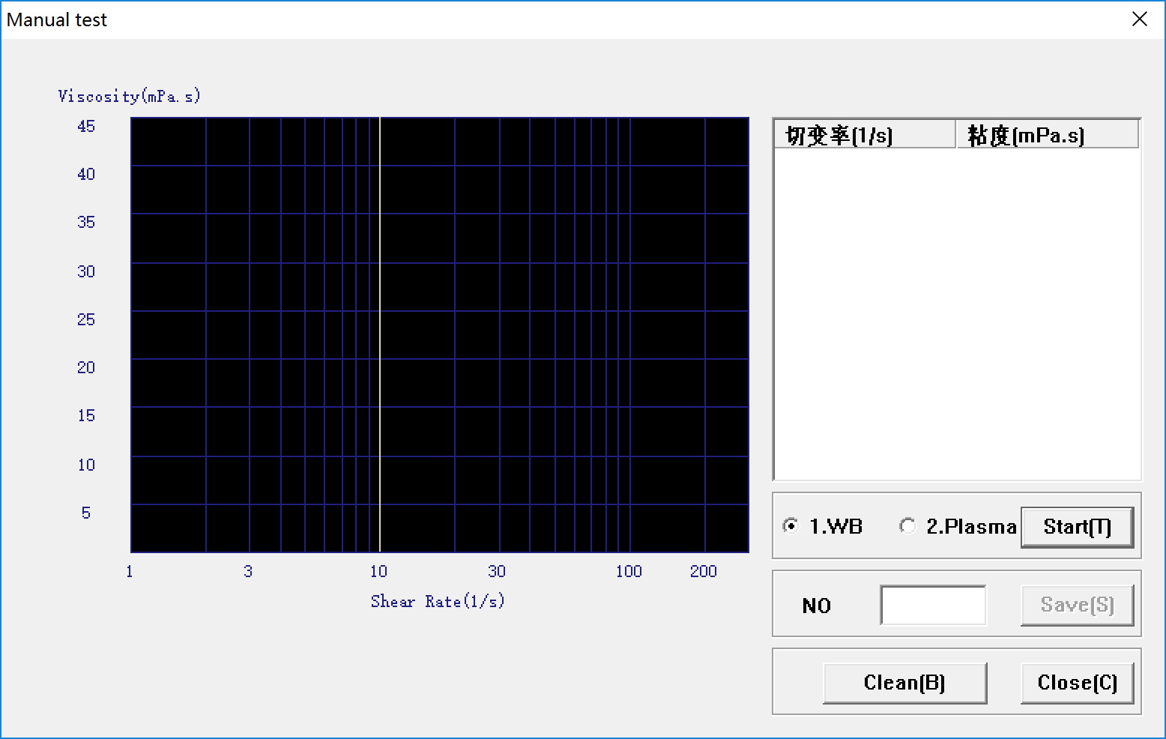
Fig. 20 Manual test interface
切变率 / 粘度 / WB / 血浆 /序号 | Shear rate / viscosity / whole blood

8-5 “Non- Newtonian quality control” menu item operation
Click on the “Non-Newtonian quality control” menu item to enter [Non-Newtonian quality control interface] (see Fig. 21), this function can only be used in Non-Newtonian quality control liquid test. This function is used to test the accuracy rate of the instrument’s test result.

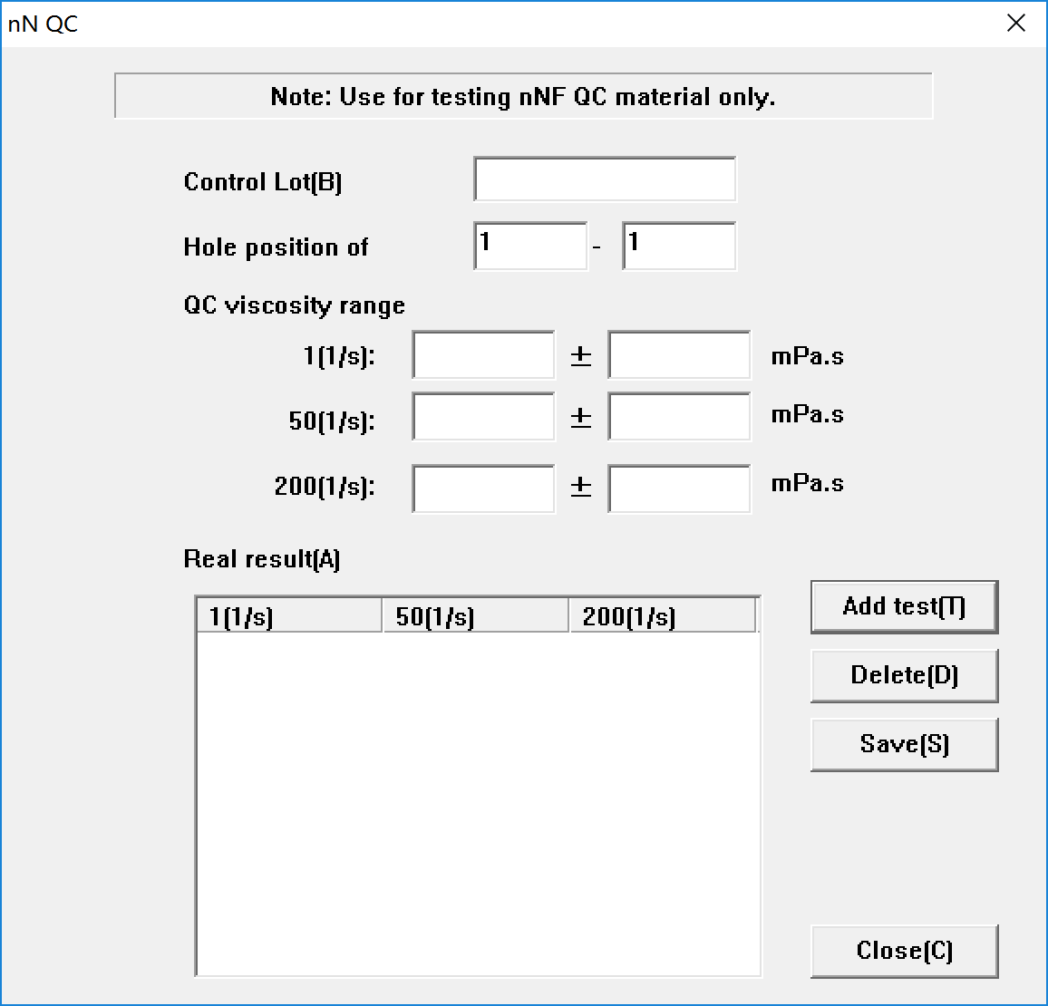
Fig. 21 Non-Newtonian quality control interface
Input the starting hole number and terminating hole number according to the test tube location of the non-Newtonian quality control material in the specimen disc.
Input the quality control material viscosity range under low shear rate and high shear rate according to the nominal value of the quality control material, click on the “add test” button, the instrument starts to test.
The actual test value of non-Newtonian quality control material viscosity reveals in the blank, you can delete the actual test value you do not need by the “delete” button.

8-6“User information” menu item operation
Click on the “User information” menu item to enter “User information interface”, input user’s name in the unit mane place, click on the “apply” button to affirm the content you input, and click on the “OK” button to save this operation. You can set or modify the user’s name of test report by this function.

8-7 “External instrument” menu item operation
Click on the “external instrument” button to enter the [External instrument interface] (see Fig. 22), in the blank, are the external instruments name preset by the manufacturer for the user to select.
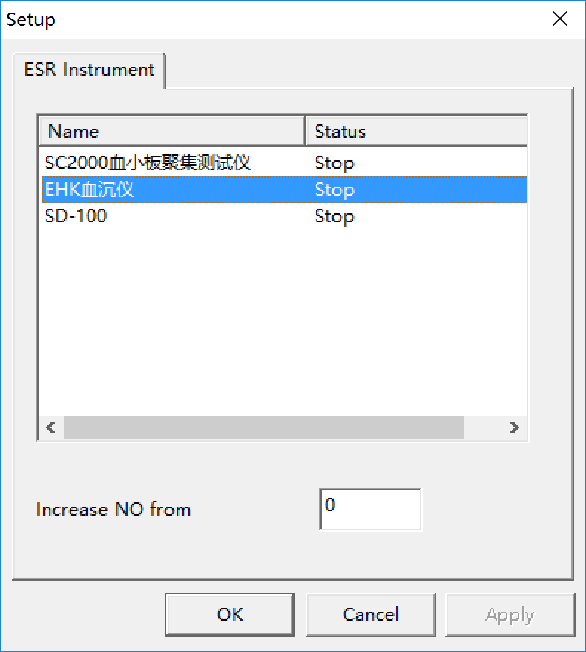
Fig. 22 External instrument interface
Increase NO from | Increase number from external analyzer

Pitch on the inline external instrument name, then the characters will be covered by blue strip, click on the right mouse button, you can choose the following operations in the dialog box:
— Click on the “allocate” to enter the communication port setting dialog box, and affirm communication port.
— Click on the “startup” can upload the test data of the external instrument.
— Click on the “stop” to stop external instruments test data transmission.

8-8 “Network” menu item operation
Click on the “Network” menu item to enter [Network setting interface] (see Fig. 23) , two optional transmission modes are offered in this interface, choose the transmission mode you need according to actual situation, realize networking function and transmit data.
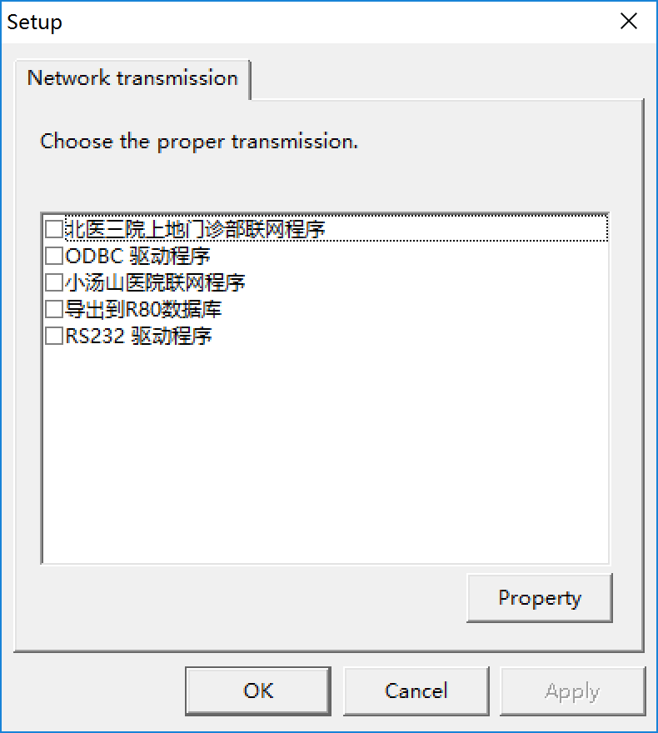
Fig. 23 Network setting interface
设置 / 网络传输 | Set / network transmission
下面是可供选择的传输方式，请选中传输方式以告诉程序使用哪种方式传输 | Below are optional transmission, please choose the proper one
驱动程序 / 属性 / 确定 / 取消 / 应用 | Drivers / property / ok / cancel / apply

8-9 “Normal(N) value” menu item operation
Click on the “N value” menu item to enter [Normal value interface] (see Fig. 24),and set normal value for the expanded items of the “test result”, “conversion result”, “other result” and “chemical result”, meanwhile, you can set colors for the displayed value of the test result higher or lower than the normal value. After completing setting, click on the “×” button to save this operation.
The “＋” before the item is a fold mark which means that this item can be unfolded. Clicking this mark can unfold this item in ladder form. Meanwhile , the mark will turn into “－”, named unfold mark, clicking the unfold mark can fold the item.
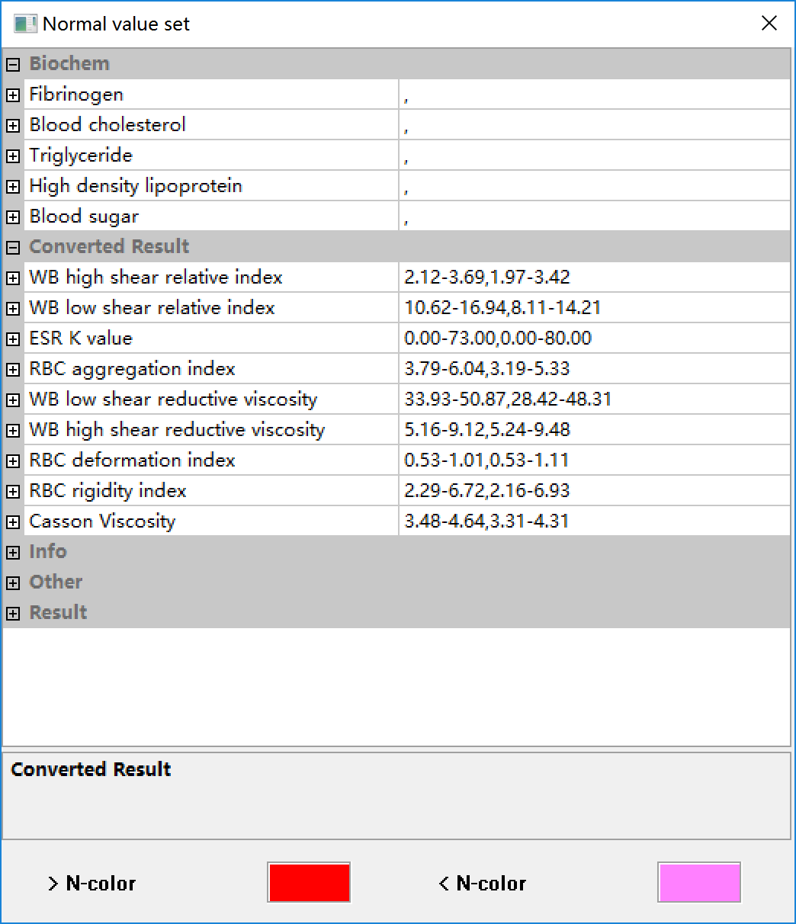
Fig. 24 Normal value interface
WB | Whole blood (WB)
shear | Shear rate (shear)

8-10 “Alarm limit” menu item operation
Click on the “alarm limit” menu item to enter [Alarm limit interface] (see Fig. 25). This interface is divided into cone-plate alarm setting and capillary alarm setting. You can set alarm limit for whole blood high shear rate viscosity, Whole blood low shear rate viscosity, and plasma viscosity (cone plate) in cone-plate alarm setting, and set alarm limit for plasma viscosity (capillary) in capillary alarm setting. Choose one process mode in these four process modes according to the need, click on the “apply” button to confirm the information stated above, and then click on the “OK” button to save this operation.
During the test, if the outcome test value exceeds the alarm limit, the test program will alarm with a “Di-di” alarming tone. And the “” button in the toolbar will turn into clickable state, click on the button to stop the alarming tone.
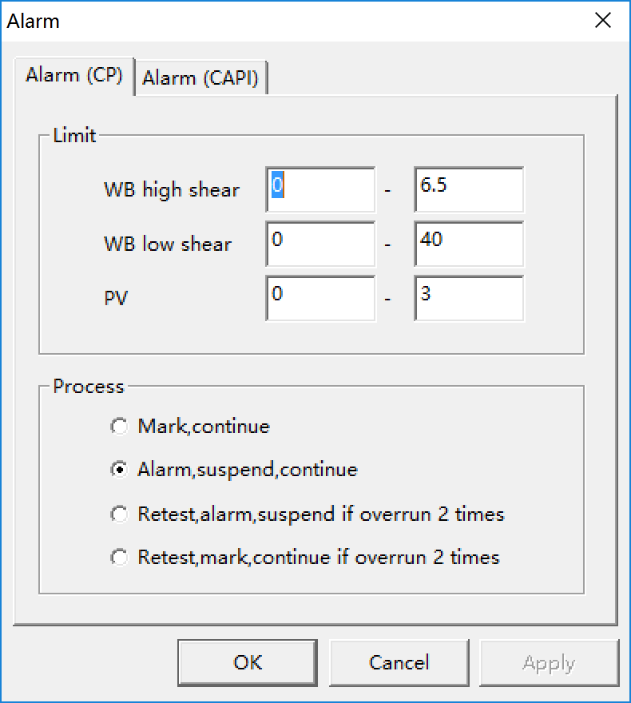
Fig. 25 Alarm limit interface
CP | Cone plate
CAPI | Capillary
shear | shear rate (shear)
Mark, continue | Mark, continue with next sample
Alarm, suspend, continue | Alarm, suspend test, continue after processing

8-11 “Shear rate” menu item operation
Click on the “Shear rate” menu item to enter the [Shear rate interface] (see Fig. 26). You can “alter”, “delete” or “add” shear rate in this interface.
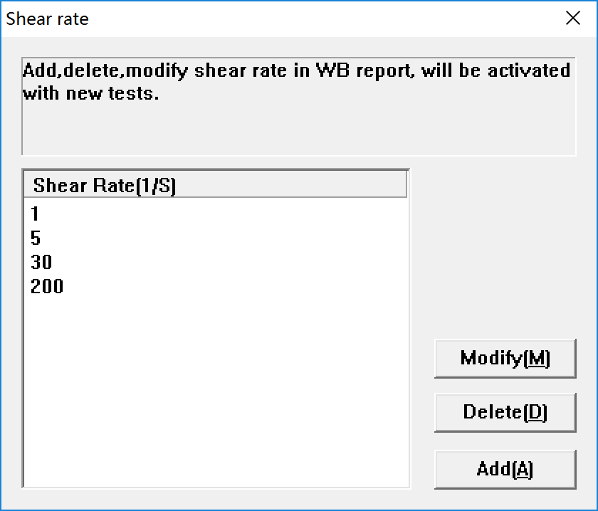
Fig. 26 Shear rate interface
8-11.1 Alter: pitch on the shear rate need to be altered, the number will be covered by blue strip, click on the “alter” button, and input the new shear rate.
8-11.2 Delete: pitch on the shear rate to be deleted, the number will be covered by blue strip, click on the “delete” button to shear rate.
8-11.3 Add: when need to add shear rate, click on the “add” button, an “input shear rate dialog box” will appear, input the shear rate required, and click on the “OK” button to complete this operation.
8-11.4 After setting the shear rate, click on the “×”button to save the shear rate you set.

8-12 “Test item” menu item operation
Click on the “Test item” menu item to enter [Test item interface] (see Fig. 27), you can “add”, “delete” and “alter” the items of the following five data types (test result, conversion result, basic information, other result and chemical result), or reset the item order.
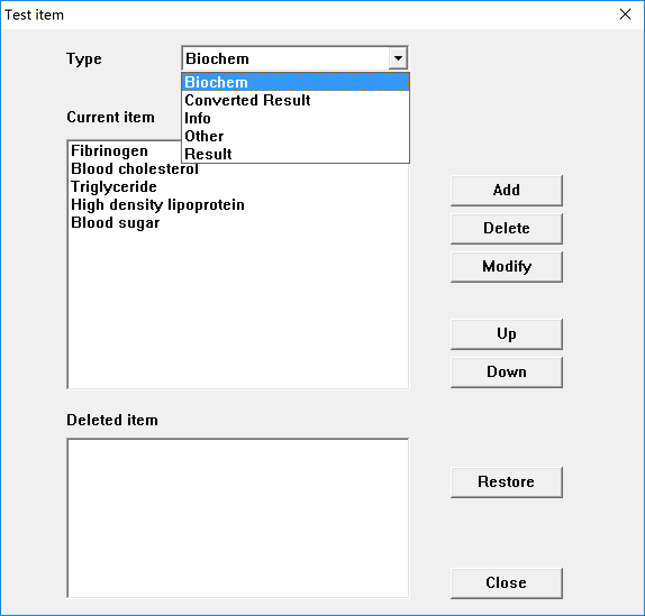
Fig. 27[Test item interface]

8-13 “Library” menu item operation
Click on the “Library” menu item to enter [Library interface] (see Fig. 28) . Preset the medicinal classification, submitting physician, testing physician, verification physician, inpatient area, bed number, clinical diagnosis, and testing purpose in this interface. The items stated above are the sameto the patient basic information input form items of the [Input interface].. the items in patients basic information input sheet in the [Input interface] (see Fig. 12) .The preset content is the content in the drop-down box of the items for the operating personnel’s selection, so as to save time in batch input of the patients’ basic information.
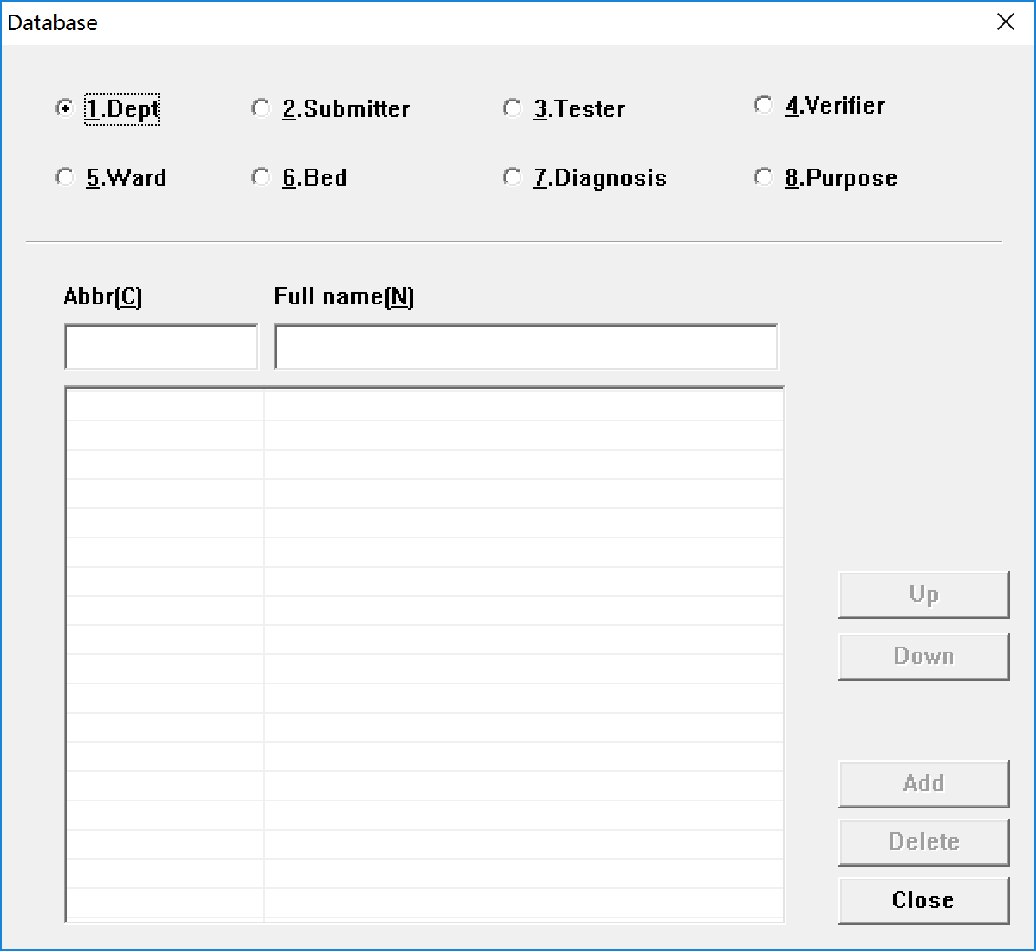
Fig. 28 Library interface

8-14 “Analysis report” menu item operation
Click on the “Analysis report” menu item to enter [Analysis report interface] (see Fig. 29). If any anomalies happen to the test result, corresponding abnormal results analysis will display in the “result analysis” of the [Test result display interface] (see Fig. 15). The user can edit the analysis content.
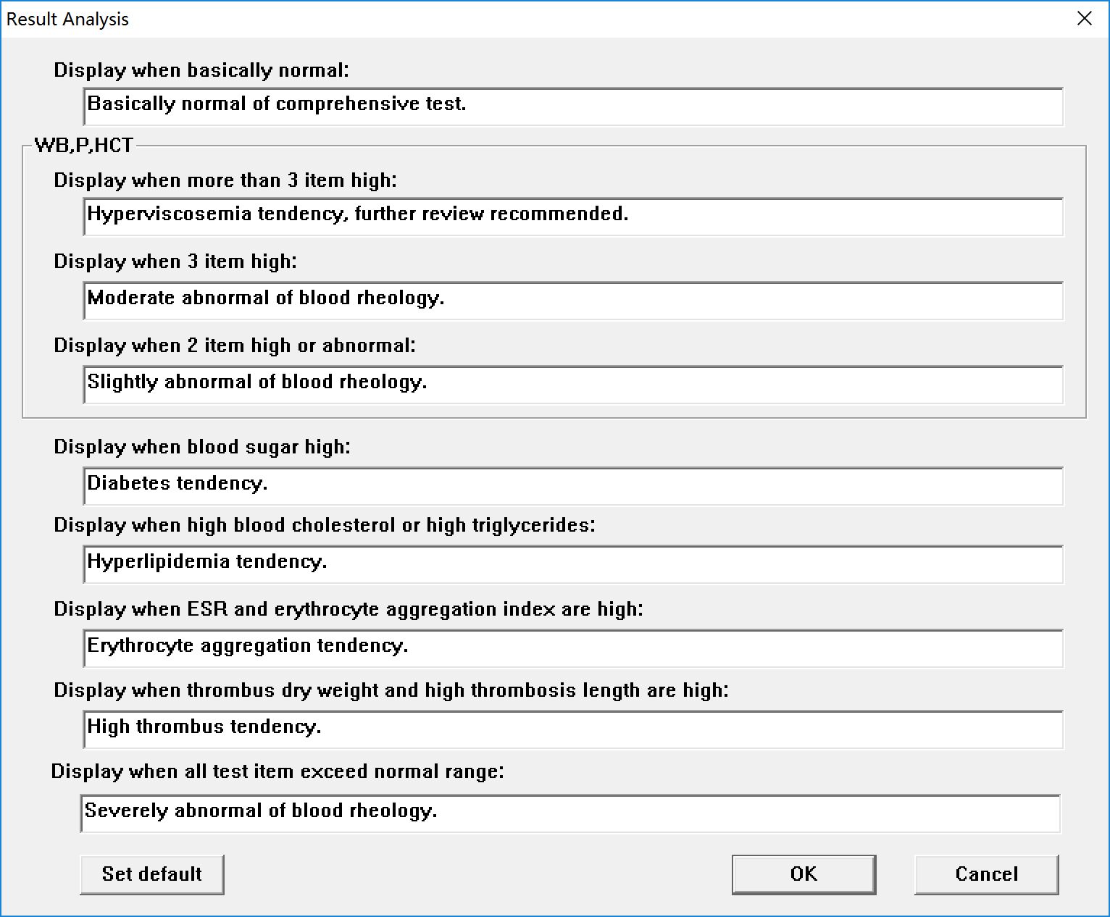
Fig. 29 Analysis report interface

9 Test report design
The users can design the item, format, style, and typeface, etc. of the test report themselves according to the need. The users can also choose the customized test report model of the manufacturer. Click on the “Edit Style” item of the [Report] menu item, select corresponding menu items in the drop-down menu to enter the [Test report interface] (see Fig. 30).
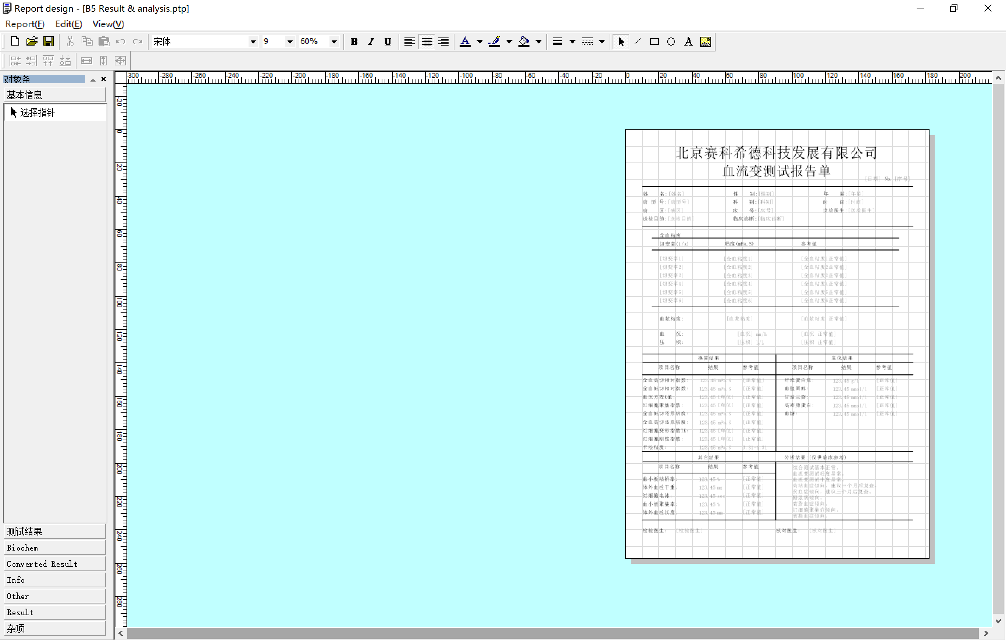
Toolbar
Menu bar
Scale plate
Fig. 30 Test report interface

9-1 Custom report
This software provides eight preset test report models. Pitch on the model you need to enter [Test report interface], the user can alter the test report sample on the basis of the model. Selecting the preset test report model or making modification on the basis of the model can help the user to reduce initialization work load.

9-2 New report
Click on the “New” menu item to enter [Test report interface] (see Fig. 30). The menu bar includes the following menu items: [Report]、[Edit]、and [Check]. The submenu of the [Report] menu item provides the following operations on the report: new, open, save, save as, page setup, and select reports, etc.; The submenu of the [Edit] menu item provides editing operations on the selected object items; The submenu of the [Check] menu item provides the functions to show or hide the object items, toolbar, scale plate, and grid.
9-2.1 Click on the “object item” menu item, the [Object item interface] (see Fig. 31). The interface has two display formats: folding (the left-hand chart) and expansion (the right-hand chart). Clicking on the title bar of the object item can switch between the two display formats.
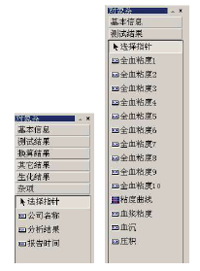
Fig. 31 Object item interface
基本信息 / 测试结果 | Basic information / Test result
测试结果 / 换算结果 / 其他结果 / 生化结果 / 杂项 | Test result / Converted result / other result / biochemistry result / others
选择指针 / 公司名称 / 分析结果 / 报告时间 | Selective cursor / company name / analysis result / report time
全血粘度 / 粘度曲线 / 血浆粘度 / 血沉 / 压积 | Whole blood viscosity / viscosity curve / plasma viscosity / ESR / HCT

9-2.2 Click on applicable object item, the object item background turns white. Move the mouse to appropriate place of the blank report, click the left mouse button, and release the selected object item, by this time, the characters in the object item has two colors: deep color and light color. Pitch on the deep-color character with the mouse, double click the left mouse button to enter the “text editing dialog box”, and change the text; the light-color characters are the software setting access code, and cannot be changed by the user.
9-2.3 Edit the items and applicable format of the report by using the editing functions offered by the toolbar.
9-2.4 Name the new report model and save all the designs for use.

10 Sample collection and preparation (Note: only for clinical reference)

10-1 Anticoagulant selecting and dosage
10-1.1 Anticoagulant selecting: It is advisable to choose and use heparin as anticoagulant. It is inadvisable to use oxalate and sodium citrate for that they may cause cell shrinkage, influence aggregation and deformability of erythrocyte, and cause blood viscosity rising.
10-1.2 Anticoagulant dosage: the heparin anticoagulant concentration is (10～20) IU/ml whole blood. It is suitable to use solid-phase anticoagulant or high concentration liquid-phase anticoagulant. In case that liquid-phase anticoagulant is used directly, then its dilution effect to the blood shall be taken into consideration. The same batch test shall use homogeneous anticoagulant of the same batch.
10-1.3 Making anticoagulant tube: If liquid-phase anticoagulant is applied in the test, it shall be carried with the dry glass tube or glass bottle. The glass tube or glass bottle shall be dried in the oven before use, and the drying temperature shall be controlled under 56℃.
☆ Notice: Excessive anticoagulant dosage is not appropriate, for it has dilution effect to the blood; insufficient anticoagulant dosage is not appropriate, for it will not reach anticoagulant effect.

10-2 Sample collection
10-2.1 Time: generally, it is advisable to sample blood under fasting, resting state in the morning.
10-2.2 Location: take sitting position while blood sampling, and collect antecubital venous blood.
10-2.3 Make the vein block time as short as possible while blood sampling. Loosen the tourniquet immediately after piercing the syringe needle in the blood vessel, and start to sample blood after stilling for five seconds.
10-2.4 To avoid that shear force injures the erythrocyte, the blood sampling shall not be too fast. So, the blood adding sample probe shall have a wide internal diameter (syringe needles bigger than size 7 needle are the best). Blood sampling draft shall not be too strong, or it will cause abnormal shear force when the blood flows through the syringe needle.
10-2.5 Blood sample blending: After blood sampling, screw off the needle. Inject the blood into the tube along the tube wall slowly. Hold the middle part of the tube and roll it or make circling sliding on the table, in order to mix the blood and anticoagulant thoroughly and avoid blood coagulation. But violent shaking shall be avoided, for fear of hemolysis.

10-3 Blood plasma preparation
Use clinical routine method to prepare plasma, centrifugal force 2300×g, left and right centrifuging for 30 minutes, extract upper plasma, and use it in plasma viscosity test.

10-4 Sample storage
10-4.1 Storage temperature: the storage temperature of blood sample shall not be lower than 0℃. Under freezing condition, the physiological status and rheological behavior of the blood will be influenced. So, blood sample is often kept under indoor temperature ((15～25)℃.
10-4.2 Storage period: generally, blood sample test will be completed in four hours under indoor temperature. But if the blood sample is tested immediately after blood sampling, then the test result will be lower, soit is advisable to test the blood sample after stilling the blood sample for twenty minutes.
10-4.3 The storage temperature of blood sample shall not be lower than 0℃. As for exceptional case, if the blood sample storage period must be prolonged, then it shall be kept in the refrigerator of 4 ℃. Generally, the storage period shall not exceed twelve hours. The blood sample shall be shaken up thoroughly before test, and give clear indication of storage condition in the result report.

11. Routine maintenance
Beijing Succeeder Technology Inc. shall ensure the product quality of SA-7000/SA-9000 fully automated blood rheology analyzer. If any product quality defects occur in normal operation and placement, Succeeder guarantee to repair or replace in time. The instrument may need to be returned back during the guarantee period, so please well preserve the packaging and relevant payment certificates.
Keeping good working environment and avoiding inadvertent faulty operation is an important element to keep good performance and increase of service life of the instrument.
➢ SA-7000/SA-9000 fully automated blood rheology analyzer provides one year free warranty and lifetime paid maintenance services.
➢ Please preserve the original package of the instrument for use during maintenance transportation.
➢ When operating, please keep the operation surface clean, and wipe the dirt on the surface with neutral cleaning fluid. Solvent liquid (like ethyl alcohol) is forbidden to be used.
Under the following situations, please turn off the power, unplug the power cord, and ask professionals to maintain:
➢ When the power line, signal line or plug is broken or fractured;
➢ The instrument is exposed in rain or water;
➢ The instrument is dropped and broken, or the casing is damaged;
➢ The instrument cannot work correctly even if operate according to the normal operation guidance of the operation instruction.
➢ Instrument characteristics have obvious changes.If the significant change of the instrument characteristics cannot be eliminated after eliminating elements such as sample, standard attachments, and manual operation, that means the instrument need repairing;
➢ The power tube of the instrument is damaged or significant sample adding amount inaccuracy occurs.
If the users do not operate in accordance with this instruction book, Succeeder will not provide warranty for any direct, indirect, or accidental damage of SA-7000/SA-9000 fully automated blood rheology analyzer caused by this.
Succeeder will not provide warranty for any modification of the SA-7000/SA-9000 fully automated blood rheology analyzer without Succeeder’s authorization.
It is inconvenience to provide some of the technical material in this instruction book, Succeeder promise to provide relevant technical material if the user needs.

12. Basic troubles shooting
Fault phenomenon I: On-line error, “test component connection failure” or communication error of inconclusive plate circuits.
Re-plug the USB cable, or change the USB cable.
Fault phenomenon II: Feeding water failure in cleaning
Check whether the c leaning liquid tube is under the liquid level, or whether the cleaning liquid is used up.
Fault phenomenon III: Blood plasma page interaction sample sucking failure
Insufficient blood sample collection
Fault phenomenon IV: Movement tacho-generator failure, driving force output error
Take out the centering bell, clean the blood cutting board, and back online.
Fault phenomenon V: Test results abnormal
Anticoagulant error; nonstandard blood drawing; the whole blood has not been mixed before test; nonstandard blood plasma centrifugation; Cleaning liquid preparation error, or Cleaning liquid failure.
Fault phenomenon VI: Value output failure during test time
Check whether the “pause” button is on work; restart the instrument and software, clean the liquid pool, and test again; check whether the centering bell is in place.

